Contents Page

Acknowledgements ……………………………………………………………………………. ii
Abstract iii
CHAPTER 1 Introduction 1
1.1 Context 1
1.2 Rationale for study 1
1.3 Research Aim and Objectives 2
CHAPTER 2 Literature Review 3
2.1 Intrinsic Motivation 3
2.2 Extrinsic Motivation 4
2.3 Achievement Motivation 5
2.4 Personality Traits 6
2.5 Social and Cultural Influences 8
2.6 Futsal and Football Participation 9
2.7 Summary 10
CHAPTER 3 Methodology 11
3.1 Philosophical Underpinning 11
3.2 Research Methods 13
3.3 Ethical Implications 15
CHAPTER 4 Results and Discussion 17
4.1 Result 1 17
4.2 Result 2 19
4.3 Result 3 23
4.4 Result 4 26
CHAPTER 5 Conclusion 28
References 30

Appendices 1. Progress Record Form
2. Research Paradigms 39
3. Online Questionnaire 39
4. Pilot Questionnaire Feedback Sheet 43
5. Interview Questions 43
6. Interview Transcript Accuracy Confirmation 45
7. Coded Transcript 46
8. Respondents views on futsal participants being more tactically aware, thinking more and better technical ability 58
9. Respondents views on 11-a-side football being more physical and aggressive……………………………………………………………………………………….. 58
10. Respondents beliefs on English culture not liking change 59
11. Respondents views on futsal offering a more competitive structure than small-sided football........................................................................................................... 59
12. Respondents views on futsal being more expensive in contrast to football’s jumpers for goalposts approach........................................................................ 60

Acknowledgments
I would firstly like to thank my project supervisor Chris Cutforth who has supported me throughout completing this dissertation. Chris has always offered his time and advice as well as challenging me during the dissertation process which has improved professional thinking and judgement.
I would also like to thank the whole Sport Development with Coaching staff who throughout the 3 years have helped me to develop both professionally and personally, in particular Jude Langdon who has always spared the time to discuss and offer advice about work placement opportunities and my future after this course.
I would also like to thank all of the interviewees and questionnaire respondents who participated in the data collection of this study, who without, I would not have been able to develop the key results and findings to achieve my research aim and objectives.
Lastly, I would like to thank all of my family and friends who have supported me throughout the last 3 years, helped me to develop personally and have given me some enjoyable memories throughout my whole university experience.

Abstract
In England there is currently a participation trend whereby 11-a-side football is decreasing whilst small-sided football and futsal is increasing. Due to futsal being a relatively new sport in England with increasing participation there is a need for sport development professionals to understand what is motivating adults to start playing this new sport to English culture instead of more traditional versions such as 11-a-side football and small-sided football formats like 5-a-side or 6-a-side. Therefore this study aims to understand the motivations and influences for adults choosing to play different formats with the research objectives aiming to develop an understanding of motives and influences for an adult to choose futsal over more traditional football formats as well as why an adult would not choose to play futsal over other football formats. Additionally, this study aims to provide evidence-based research for sport development professionals to use when planning and justifying new participation programmes. The literature provided key areas to consider on what may form an adult’s motivation or influence their decision including intrinsic, extrinsic and achievement motivation, personality traits as well as social and cultural influences that provide barriers to participation. A pragmatic approach was adopted using mixed methods to collect data which included purposive sampling semi-structured interviews with 4 interviewees geographically spread across England. Also, a random sampling online questionnaire was distributed across social media networks and was completed by 148 respondents. These methods sought to receive adult’s responses and explanations on what format they currently play or previously played, their opinions on if they perceive each format’s participants to have different personalities or characteristics, their motives for choosing a specific format and other influences or barriers that cause or prevent them choosing a specific format. The results from the data collection indicate that futsal participants possess more introvert traits, scoring higher than 11-a-side football participants for motives such as learning/developing new skills, challenging themselves and fitness. Whereas 11-a-side football participants demonstrated more extrovert traits than futsal participants, scoring higher for motives such as earning money, winning trophies and socialising. Futsal participants also appeared to have more introvert traits than small-sided football participants by scoring higher for internal motives like learning/developing new skills and challenging themselves. In contrast to small-sided football participants who scored higher for the external motive of socialising. Additionally, the results indicated lack of awareness, facilities, transport and location were higher scoring barriers to futsal participation than 11-a-side and small-sided football participation. It is concluded that the key findings and results found in this study has achieved the research aims and objectives providing knowledge on what motivates and influences an adult to choose to participate or not in futsal over other football formats.

1. Introduction
1.1. Context
This study will investigate the motivations and influences on an adults’ decisions to play a specific football format in England, looking at the differences in motivation between futsal, 11-a-side football and small-sided football participants. There is currently a lack of futsal research available in the English language (Moore and Radford, 2014) and even less research into current futsal participation. Futsal is recognised as being a relatively new sport in England (FA, 2014). Despite this, futsal is also recognised as being the fastest growing indoor sport in the world (Rose, 2013). Although futsal is seen as a popular sport in most European and South American countries, there is a low level and a need to understand the participation rates in England and how to increase these figures to develop the sport.
The most recent English futsal participation statistics in 2014 showed that there are 20,132 adult participants which represents a 38% increase from 2013 (Leicestershire & Rutland County FA, 2014). Since then there has been no official publication of English futsal participation statistics although there are estimates of 25,000 participants being the current figure (Radford, 2016). Although these participation figures would make futsal one of the lowest participated sports in the country this can be seen in context due to the sport being new to England. However, despite being a new sport to England it is rapidly increasing in participation with claims amongst the futsal community of it being the fastest growing in sport, in the UK, in contrast to football where the overall participation percentage is 4.21% (Sport England, 2016), making football one of the most participated sports. The number of participants playing 11-a-side football at least once a week is in a decline dropping from 1.51% in 2013/14 to 1.29% in 2015/16 (Sport England, 2016). Meanwhile the number of participants playing small sided-football outdoors at least once a week has been continuously increasing from 1.66% in 2013/14 to 1.78% in 2015/16 (Sport England, 2016).
1.2. Rationale for study
This topic has been chosen with the purpose of providing futsal research in the English language centred on participation, specifically in England. Moore et al (2014) suggest that there is a need to fill in the knowledge gaps around futsal in order for the sport to develop. In addition, whilst interpretations can be made and applied from other sports, particularly football, about similarities and differences in the motives and influences to play futsal or the barriers of futsal participation, this can never be definitive without specifically researching into futsal as they are assumptions based on other sports.
The current situation with regards to different football formats has shown 11-a-side football participation decreasing, small-sided football participation increasing and futsal participation increasing or estimated to be increasing thus suggesting that more people are preferring small-sided versions including futsal than the 11-a-side game. It has been highlighted by the FA and the media the need to understand why this trend is occurring and rapidly growing with concerns over the future for England’s national sport and the worry of what might happen to the original 11-a-side format of football (Roan, 2008). However despite the worry of the 11-a-side game’s future, the FA take ownership of small-sided football, including futsal (FA, 2017). Amongst the futsal community there are significant claims of the FA not taking futsal seriously and promoting it. This claim is understandable as there was no specific mention of futsal in the FA National Game Strategy 2011-2015 (FA, 2011) or currently in the FA National Game Strategy for Participation and Development 2015-2019 (FA, 2015). Due to futsal being acknowledged as a new sport to England, it is possible that sport and football development officers as well as County FA’s who are responsible for increasing participation in all formats may not have knowledge of how to attract people to play futsal or understand why people are already playing it. Additionally, there is a demand for evidence-based research to help sport policy makers when planning and making decisions on a sport’s policy and practice. When sport policy makers do not have evidence-based research to assist their decision making they are left to make informed decisions (Coalter, 2007).
1.3. Research Aim and Objectives
The aim of this research is to develop an understanding of why adults would choose or do not choose to participate in futsal over other football formats.
The objectives of this study are to;
- Understand the motivations for adults choosing to participate in futsal over 11-a-side football.
- Understand the motivations for adults choosing to participate in futsal over other small-sided football formats. (6-a-side and traditional 5-a-side).
- Understand why participants do not play futsal instead of football.
This would then provide a better comprehension of why adult futsal participation is seemingly increasing. This research aims to serve the purpose of supplying sport and football policy makers as well as development officers with data and knowledge they can use to make evidence-based policies.

2. Literature Review
2.1. Intrinsic Motivation
There are many reasons for why people choose to participate in sport. However, Vallerand and Young (2014) state that many sport and physical activity programmes are being created to align with individuals’ personal motivations. One type of personal motivation is intrinsic motivation. Intrinsic motivation can be when a person engages ‘in an activity in the apparent absence of extrinsic rewards or constraints’ and also defined as ‘if they express interest in and enjoyment of the activity’ (Vallerand, Deci and Ryan, 1987). In order to better understand intrinsic motivation, many theories have been developed that links intrinsic motivation to cognitive psychology, social development and self-theories in which they believe social influences can have an impact on the thinking of individuals (Deci and Ryan, 1991). An example of an intrinsic motivation theory is the self-determination theory. This theory is based on the hypothesis that people’s behaviour is motivated by three psychological needs. These being autonomy, competence and relatedness to others (Frederick-Recascino and Schuster-Smith, 2003). The self-determination theory is claimed to demonstrate how intrinsic motivation can cause people when in sport to develop their skills which could be in all contexts such as technical, social, psychological and physical. It is further claimed to develop persistence and competitiveness (Frederick and Ryan, 1993; 1995). This could be because of the sense of self-achievement that occurs for an intrinsically motivated person. Feelings of autonomy and competence are achieved when a person participates in a sport of their choosing and plays at a level or intensity that they find challenging. As a result of achieving these feelings, the participant may feel more motivated and determined to continue practicing and repeating the same skill to achieve perfection (Frederick-Recascino and Schuster-Smith, 2003). An example of this would be a footballer who practices the same free-kick repeatedly or a golfer practicing the same swing over and over again Ryan and Deci (2009) state that when these psychological needs for autonomy and competence are met, it results in the person finding that activity enjoyable.
Although, Pederson (2002) says that ‘intrinsic factors are not independent of extrinsic factors’ and that the Cognitive Evaluation Theory suggests an individual’s sense of competence and self-determination is contemplated to be an effect of external rewards such as control and information. An example of this would be if a player is awarded positive feedback from their coach, by receiving positive external feedback it helps to improve their own self-esteem and competence. Additionally, if a player is given negative feedback or no feedback at all this could lead to a loss of intrinsic motivation. A player may also suffer a decrease of intrinsic motivation if they feel under pressure by the coach to perform to a certain level of expectancy (Pederson, 2002). This is because the person participating in the sport for intrinsic reasons, such as enjoyment or if the coach is putting pressure on them, will not find the sport enjoyable as performance would not be the main priority for them. However, in some cases the intrinsically motivated person may put pressure on themselves if they are under performing as they may want to master a skill for self-achievement and satisfaction. Therefore, if a coach is adding even more pressure onto them, this will only contribute to the decrease of intrinsic motivation. Jones (2014) suggests that intrinsic motivation can be affected either positively or negatively, depending on how a reward is perceived. For example, if the coach says a player will be rewarded by winning the man of the match trophy for performing well, this will reduce the person’s autonomy because it is seen as controlling. Whereas, if a player is given praise by the coach it is seen as informational and helps their feelings of competence. (Jones, 2014).
2.2. Extrinsic Motivation
Extrinsic motivation is defined when a person is motivated by ‘external rewards such as praise, money and trophies’ (Kent, 2016). Other extrinsic motivation factors include publicity and fame, also rewards such as scholarships and professional contracts can be motives for young athletes (Hatch, Thomsen and Waldron, 2016). In relation to the research objectives, extrinsic motivation factors could provide some insight into why some adults choose not to play futsal over football. Extrinsically motivated athletes are claimed to show more concern with the competitive or performance outcome (Hatch, Thomsen and Waldron, 2016). The aforementioned are all positive external rewards that some athletes are motivated by, however, some athletes are motivated by negative external rewards such as avoiding criticism from others and avoiding punishments (Hatch, Thomsen and Waldron, 2016). An example of avoiding punishments may be when a coach says the losing team have to run laps around the pitch. This will motivate the player to not lose and try more in order to win or in some cases may cause the player to win at all costs through non sportsman-like behaviour.
Weinburg and Gould (2015) suggest that the nature of sports lends itself to make participants extrinsically motivated. This is because of the post season awards nights that most clubs and leagues have which involves handing out trophies and medals, and also rewards such as free t-shirts for attending exercise classes (Weinburg and Gold, 2015). Condry (1977) suggests that when external rewards are used as motives, it usually causes people to be slower in solving problems and more likely in making mistakes. Additionally, Kohn (1999) claims that external rewards also creates a result-focused mind-set. An example of when these affects may occur could be during a cup final match where the teams know that a trophy is the reward for winning. This may cause teams to take longer in tactically overcoming the opposition or make more mistakes such as poor technical execution, mistimed runs and poor decision making. It may also cause players to cheat in order to win due to the result fixation as players become desperate to win the rewards. An example of this would be the FIFA World Cup 1986 when Diego Maradona famously hand-balled against England to score the winning goal and progress into the semi-finals.
To some extent, the nature of being a footballer is associated with trophies, fame and money. Brodie (2016) explains that these extrinsic factors are often demonstrated when footballers choose to leave and join a different club with reasons being linked to earning more money or more chance of achieving success such as winning trophies. Brodie (2016) also describes football as being a result-driven business with club owners and supporters putting pressure on the management and players to achieve success. With these considerations, it is understandable why many choose to participate in football and aim to play professionally due to the glamorous lifestyle associated with it because of the trophies, high wages and fame. In contrast to this, futsal in England is still an amateur sport at the highest level, which for an extrinsically motivated person we could predict would be less attractive to participate in when compared to the extrinsic benefits of football. However, an extrinsic factor for choosing to play futsal over football could be for the publicity of playing a sport that is said to revolve around skilful and creative play (FA, 2009). Therefore, if somebody plays futsal there may be an association of that individual being a skilful and creative player which is the desired type of player the FA are aiming to develop through the new ‘DNA’ player development programme (FA, 2015).
2.3. Achievement Motivation
Achievement Motivation is defined as a ‘motive that induces a person to direct his or her behaviour toward the attainment of certain goals’ (Kent, 2016). This type of motivation comes in two different formats known as ‘nach’ which is the need to achieve and ‘naf’ which is the need to avoid failure (Teach PE, 2017). An example of nach motivation would be when somebody chooses to play in a team with more skilful players than themselves in order to challenge themselves. In contrast, naf motivation is where somebody will choose to play in a team with players of a lower ability level than themselves to avoid the risk of failing. Brain (2002) claims that people who have a good level of performance or are successful in sport have a high level of nach and a low level of naf motivation. Alternatively, those who do not perform well or succeed in sport are said to have low nach and high naf motivation (Brain, 2002). Achievement motivation needs further consideration with regards to what may cause somebody to have a higher level of nach or naf motivation. This consideration is concerned with the goal orientations of the individual. A task goal oriented person in futsal or football may define themselves by beating their own goal scoring record. Whereas somebody who is outcome goal oriented is focused ‘on winning, and what the outcome is, rather than on their own performance’ (Brain, 2002).
All of these types of behaviours and motives can be linked together due to the similarities. The first link we could interpret is that people who are task goal oriented, also have high nach motivation due to the characteristics of challenging themselves. As a result of these characteristics we could suggest that people who are task goal oriented and experience high levels of nach motivation are intrinsically motivated people. Opposite to this, links can be made between outcome goal oriented and naf motivation. This link can be made due to the outcome focus of winning to avoid the failure of losing. Therefore, we can also interpet that people who are outcome goal oriented and naf motivated are extrinsically motivated people.
It is believed that the majority of sports people have high levels of nach motivation (PE Teach, 2017). However, this would arguably suggest that most sports participants are intrinsically motivated, which can be questioned due to the potential extrinsic rewards that can occur in sports.
2.4. Personality Traits
There are many studies which suggest that an individual’s choice of sport participation is related to their personality. The most common theory is that introverts are more likely to play individual sports and extroverts are more likely to play team sports due to the characteristics of these type of people (Gomez, 2015). Introverts are described as being shy and reserved people who prefer activities that require refined skills and repetitive actions which involve high levels of concentration (Adams, Gledhill and Phillippo, 2012). They are also recognised as having the ability to motivate themselves without the help of others (Adams, Gledhill and Phillippo, 2012). Whereas, extroverts are defined as loud and sociable people who are believed to have lower levels of concentration, with a preference for participating in exciting and unpredictable activities (Adams, Gledhill and Phillipo, 2012: Barker et al, 2010).
If personality characteristics can affect an individual’s choice of sport participation, then we can suggest from the trait theory that those who play either futsal or football are more likely to be extroverts. However, this project shall aim to distinguish the potential differences and reasoning between those who choose to play futsal and those who choose to play football or other small-sided formats. The risk of generalising all team sport participants as extroverts is that we contribute to this stereotype, when there is no apparent or evidential reason for introverts not playing team sports. This is supported by the Situation Approach theory which states that an individual’s type of behaviour is largely influenced by the situation or environment they find themselves to be in (Weinburg and Gould, 2010). Therefore, if an individual is surrounded by people who mostly play football instead of futsal, then they are most likely to play football over futsal as well due to it being a dominant ‘norm’ in their surroundings. Weinburg and Gould (2010) support this by stating that ‘if the influence of the environment is strong enough, the effects of personality traits will be minimal’. Despite this many sport psychologists do not embrace the situational approach and show more preference towards the theory based on personality traits influencing your behaviour and choice of sport. The argument for this is that some people will have strong enough personality traits to not be controlled by the environment or situation around them (Weinburg and Gould, 2010).
In relation to the research objectives, it can be identified that stereotypically those who play futsal or football are likely to be extroverts. However, it is important to consider that introverts may also play team sports which contradicts the trait theory. Since futsal and football in all its formats are considered different sports, this could suggest that there is some slight differences in personality and the type of people that choose to play one over the other. To hypothesise, if all team sport participants are typically characterised as extroverts, the potential difference could be introvert traits within the individuals thus suggesting that all people potentially have both introvert and extrovert traits that forms their personality, however one type of traits may be more dominant.
Extroverts are believed to prefer unpredictable activities which can be supported by the principles of invasion games such as futsal, 11-a-side football and other small-sided football formats because of the quick transitions from attacking to defending. In comparison of each other, it could be argued that extroverts may find futsal or small-sided football more attractive to participate because of the smaller pitches providing more frequent and faster transitions into the opponent’s half. Furthermore, it can be presumed that more unpredictable moments are more likely to occur in traditional 5-a-side and 6-a-side football as opposed to futsal because of the rebound walls that surround the pitch ensuring that the ball is always in play. Therefore, it could be argued that traditional 5/6-a-side provides the most unpredictable moments suited for extroverts seeking this excitement within a game.
If we hypothesise that introvert traits are what makes the slight difference between playing one team sport over another, then we can argue that those with more introvert traits may prefer to play futsal over 11-a-side football and 5/6-a-side football. This can be argued because of introverts preference for individual sports and performances (Beashel, Sibson and Taylor, 2001). Futsal offers more opportunity than football for 1v1 situations during the game as result of less players being on the pitch, this could arguably assist those with introvert traits as you are put in individual scenarios. In addition, by having less players and more individual scenarios such as 1v1, you arguably have to take more responsibility for your individual role, whereas football provides less opportunity for responsibility and individual game situations because of the much larger number of players on the pitch. This hypothesis is supported by Laborde (2016) who claims that the main psychological difference between individual and team sports is the concept of personal responsibility. Laborde (2016) claims the need to accept personal responsibility is lower in team sports than individual sports. Therefore, it is worth considering that these introvert traits may also apply to those who choose to participate in small-sided team sports. Other introvert traits such as refined skills may influence one’s decision to participate in futsal over traditional 5/6-a-side football. This may be because the ball in futsal can roll out of play just like 11-a-side football, whereas traditional 5/6-a-side does not allow the ball to be out of play with the rebound walls. Therefore, in futsal and 11-as-side football you have to hone skills such as weighting of pass to ensure the ball does not go out of play. An introvert may find this technical skill more challenging to master in futsal due to the smaller sized pitch potentially making it more difficult to weight passes to keep in play.
2.5. Social and Cultural Influences
In relation to the Situation Approach, the concept of an individual being influenced by their surroundings is further supported by Woods (2015) who suggests that friendships are one of the key factors in choosing to participate in any sport. Woods (2015) further implies that we are more likely to continue playing sport if friends reinforce us by participating themselves, however, if a person’s friends drop out of sport this may also convince them to stop participating as well. Woods (2015) argues this is because the influence of our friends becomes stronger as we get older due to becoming less dependent on family for decisions and support. Jones, Millward and Buraimo (2011) study found that the most popular people to participate in sport with was friends and the second highest answer regarding the ‘best thing’ about playing sports was socialising with other people. From these statements we could interpret that those who participate more or instead of either futsal, 11-a-side football or traditional 5/6-a-side football is arguably influenced to participate in that activity because of their social circle predominantly being involved in that activity.
Furthermore, social class and economic status are recognised as key factors affecting somebodies level of sport participation (Hasbrook, 1987). Income is stated to be one of the main reasons for why people may or may not participate in sport (Houlihan and Green, 2010). Additionally, the amount of income is also viewed as a determining factor in the type of sport an individual will choose to play or arguably has the opportunity to play based on what they can afford. This is evident when sports are labelled in reference to a specific social class group, with football being one of the most popular sports amongst the working class (Dobre-Laza, 2003). The reasoning for this is because of the ‘anyone can play’ nature of football which allows people of all backgrounds to participate because of requirements being easily accessible (Dobre-Laza, 2003). This includes cheap equipment, simple game rules, the ability to play football on a variety of different surfaces such as sloping fields and the ability to play the game in most weather conditions (Dobre-Laza, 2003). In comparison to futsal, Roberts (2001) says that participation in indoor sports requires ‘expensive purpose-built facilities to best compete’. Roberts (2001) further claims that most indoor sports clubs struggle to afford the hire price for indoor facilities. Therefore, most indoor sports club rely on funding from sponsorships, grants and membership fees. From this we can argue that it is more expensive to participate in futsal than football. A necessary kit to participate such as shin guards and footwear are approximately similar for both futsal and football in price and value. We can interpet that one possibility is a more expensive club membership fee for futsal participants, in order to contribute towards the costs of indoor venue hire. Moore and Radford (2014) support this as they identified facilities being one the main barriers to participation with increased costs making it more difficult.
From this it could be predicted that social class and income may play a significant role in futsal participation. If this is a determining factor for participants choosing to play futsal, then it is understandable why some people are choosing to play football over futsal as football is presumably considered cheaper to participate in, particularly 5/6-a-side football as this is most likely to be the cheapest activity as 5/6-a-side football teams and competitions are less structured and are not officially recognised as a sport. Whereas, futsal and 11-a-side football are official sports with more structure which involves clubs training as well as playing in competitions, in contrast to 5/6-a-side football where teams do not train and are not operated as official clubs. In review of the literature we could infer that those with a higher income are more likely to participate in futsal.
2.6. Futsal and Football Participation
Participation in football was found to be the fourth highest participated sport with 4.21% of the English population taking part at least once a week during 2015/16 (Sport England, 2016). However, this statistic has seen a decline from 2011/12 when once a week football participation in England was 4.94% (Sport England, 2016). In conjunction, the most recent English futsal participation statistics showed a 38% increase (5,517 players) in adult futsal participation between 2013 and 2014 (Leicestershire & Rutland County FA, 2014). Furthermore, Laupheimer and Berdejo-Del-Fresno (2014) support the largely stated declaration about futsal being the fastest growing sport in the world and claim that ‘English futsal participation is growing a lot’. This is believed to be a result of the acclaimed, continuous increase in the number of teams, players and competitions participating each season (Laupheimer and Berdejo-Del-Fresno, 2014). As a result of the national decrease in football participation and increase in futsal participation, we can infer that some people may be dropping out of football to play futsal instead. This theory is supported by Moore and Radford (2014) whose study results showed that out of their survey respondents, 24% only play futsal, 70% only play 5-a-side and do not play any 11-a-side football anymore. These results suggest that more participants are choosing to play small-sided football such as 5-a-side rather than the 11-a-side game. Moore and Radford (2014) results further showed that 94% of respondents think that futsal is better than other versions of 5-a-side football, with 76% believing that futsal will become more popular than the traditional 5-a-side football version.
2.7. Summary
In summary, the literature reviewed shows that futsal participation is currently increasing with football decreasing. This research will attempt to understand why adults are choosing to participate in futsal over football and other small-sided formats such as 5/6-a-side football. Theories to explain the motivations and influences on an individual’s decision to choose futsal can be interpreted from the areas reviewed such as types of motivation, types of personality and social/cultural influences. If these areas prove to play a role in adults deciding to play futsal, they may also assist in understanding why some people do not choose to partake in futsal instead of football or other small-sided formats. Therefore, this project will also look at why some people continue to choose football in any format over futsal.

3. Methodology
3.1. Philosophical Underpinning
In order to determine the research type approach for this study consideration is given to the ontological and epistemological methods. Ontology is defined as ‘what constitutes reality and how can we understand it’ (Raddon, 2016). This meaning, what knowledge is out there to be known? There are two ontological approaches known as objectivism and constructivism (Platts, 2016). Bryman (2015) defines objectivism as believing that ‘social phenomena and their meanings have existence that is independent of social actors’. Therefore believing that social phenomena is out of people’s control and that it has its own objective existence. Bryman (2015) claims that external social phenomena can affect people’s beliefs and uses culture as an example by saying that cultures have their own beliefs and values which the people within it then internalize. In other words, because something is claimed by the majority, it then becomes part of the culture’s identity which people then accept (Bryman, 2015). For example, because football is identified as one of the most traditional and popular sports in England (Chinglintseva, 2013), people may choose to play football as they believe that is what you do as part of English culture.
Constructivism is an approach which believes ‘social phenomena and their meanings are continually being accomplished by social actors’ (Bryman, 2015). This meaning, social phenomena is achieved through social interaction and is viewed as constantly changing (Bryman, 2015). In contrast to objectivism, constructivism views culture as something that is not set in stone and cannot constrain people. This approach views culture as something that can be changed by the people within it. In this context it could be argued that sports can never become traditional as the people within society create the norms, therefore sports may only ever be popular.
Furthermore, epistemology is defined as 'what constitutes valid knowledge and how can we obtain it' (Raddon, 2016). This challenges us to think about the reliability of knowledge and also about how we can discover knowledge. The first epistemological method to consider is the positivism approach which believes natural science methods should be adopted to understand the social world and phenomena, and views things deterministically, therefore believing that knowledge is obtained through facts (Collins, 2010). Positivists also think research should be value-free, meaning the knower is separated from what can be known (Dodd and Epstein, 2012) by minimising the importance of ‘free-will, emotion, chance, choice or morality’ (Collins, 2010). Positivism is associated with a deductive approach which favours quantitative methods (Anderson, 2013) such as questionnaires in order to gain statistical data.
The contrasting epistemological method is known as interpretivism which does not consider the world to have its own objective reality and existence but instead attempts to understand how humans experience the world and make life meaningful (Collins, 2010). Interpretivism takes a sociological approach by understanding the language, consciousness and shared meanings of people (Myers, 2008). Interpretivists are associated with an inductive approach which relies more on qualitative methods (Decrop, 2006) such as interviews, focus groups and observations as these allow more opportunity to discover the underlying reasons and meanings.
For the purpose of this study, the researcher has selected a pragmatism approach (See appendix 2) which focuses on using the best methods to help answer the research question (Anderson, 2013). This approach thinks of methods and approaches as a continuum where certain approaches may be more appropriate than others in different situations and does not view research philosophy as a decision of one or the other in terms of ontology and epistemology (Saunders, Lewis and Thornhill, 2009). Therefore, a combination of both qualitative and quantitative approaches are used in order to achieve the best understanding possible (Creswell, 2014). The positives to adopting a mixed method approach is that it will provide the opportunity to gain a better understanding through having the large number of respondents through quantitative statistics as well as the deeper social meanings and opinions through qualitative methods. Whereas choosing one or the other may not give you the best results or understanding due to only viewing things through one perspective. For example, only having qualitative data may not be reliable enough due to not having enough opinions as you would get through quantitative in order to best represent the majority of the population’s opinions. However, only using quantitative data may provide large numbers of views and opinions but does not offer enough opportunity to dig deeper into the meaning or reasoning behind people’s opinions.
The overall philosophical research design shall be conducted with the approach of conclusive-descriptive research. The conclusive research design has been chosen in order to generate findings and insights that can be practically useful for football, futsal or sport development professionals when making decisions (Research Methodology, 2016) with regards to increasing futsal participation or creating new futsal programmes. The type of conclusive research shall be descriptive, meaning that the purpose of this study is to identify the situation at present (Kothari, 2004). Descriptive research does not allow the researcher to control any variables therefore causing them to only report findings on what has happened or what is happening (Kothari, 2004). The strengths of descriptive research is that it allows the researcher to gain a substantial amount of data for detailed analysis (University of Southern California, 2017) due to combining qualitative and quantitative methods (Research Methodology, 2016). It also provides the opportunity to view the phenomenon in a natural and unchanged environment and ‘yield rich data that lead to important recommendations in practice’ (University of Southern California, 2017). However, some weaknesses of descriptive research is that it cannot be replicated due to the observational nature (Research Methodology, 2016) and results cannot provide definitive answers or answer hypotheses (University of Southern California, 2017). These weaknesses however do not apply much to this study due to the research objectives’ attempt to understand different motives and influences, and not to answer any hypotheses. Additionally, the researcher would argue that this study could be replicated in terms of the research methods and design approaches but would not expect a replication of this study to provide the same results due to the study being based on how things are in the present. The current present state of things during the conducting of this study may be different to the future present of this study being replicated, therefore potentially providing different results.
3.2. Research Methods
The data collection methods chosen for this study are interviews for qualitative data and online questionnaires for quantitative data. Interviews shall be conducted before the online questionnaire is distributed in order to remove the possibility of interviewees agreeing with statistics from the questionnaire because some people may feel they have to agree with something if there is a high statistical figure for that answer. Referring back to the continuum of mixed methods, this study shall rely more on quantitative data which is more common for a conclusive research design (French and Gordon, 2015). The questionnaire (see appendix 3) consists of questions that attempt to gain an understanding of the individual’s current and past participation habits in order to find out if any new participation trends are occurring as well as evidence to support the existing statistical figures on 11-a-side football participation decreasing. Another question asks respondents if they believe there are any personality or characteristics that are different between each format’s participants in an attempt to see if differences in personality traits can influence an adult’s decision. The questionnaire also involves questions that directly ask respondents for their motives and barriers they believe influence their decisions which will provide answers directly linked to the research aim and objectives of this study. Furthermore, the questionnaire provides different ways of answering including tick boxes which will help create statistical figures for comparison and comment boxes are used in some questions to provide an opportunity for respondents to explain their answers to provide an understanding of why think do or believe something. Therefore, the comment boxes provide explanations which can be used to support the qualitative explanations from the interviews which may add to the strength of an argument presented by an interviewee. The benefits of using a questionnaire is that they can be distributed geographically wide across the country (Brown, 2001) and the possibility of increasing the geographic distribution is enhanced more through putting the questionnaire online due to society’s increased usage of the Internet (Wright, 2005). This large distribution is needed so that more respondents can be achieved to replicate what most of the population would say due to looking at a whole country and not specific regions. The main weakness of questionnaires is that you receive limited answers from respondents because of the lack of opportunity to offer an explanation and the difficulty to express an opinion through writing. Whereas, interviews offer more ability to gain understanding of emotions and behaviours because there is more chance to discuss explanations behind people’s views (Wyse, 2014). Weaknesses of interviews are the small sample sizes and honesty of the interviewees (Sears and Jacko, 2007) as they may feel intimidated to give wanted answers because of the presence of the interviewer. The researcher has chosen interviews as the strongest qualitative method as the individual interviews may provide more chance of honest opinions in contrast to focus groups where participants may feel the need to agree with the opinion of the majority.
For the purpose of quantitative data collection, a random sampling method has been used in order to remove bias data collection by allowing anybody to complete the online questionnaire and therefore providing a more truthful representation in order to generalise findings (Gravetter and Forzano, 2011). The removal of bias has been attempted further by the questionnaire being accessible through different social media platforms such as Twitter and LinkedIn, potentially reaching more and different people. Additionally, the interviews have used a purposive sampling approach by selecting the interviewees (Research Methodology, 2016). In order to reduce potential bias when selecting interviewees, the researcher has approached people they do not know on a personal level and who are also highly experienced within futsal to give the best possible insight into futsal participation and therefore maybe more reliable to generalise their opinions if most interviewees have similar beliefs. Before undertaking the data collection, both methods were piloted in order to ‘identify potential problems that may affect the quality and validity of the results’ (Blessing and Chakrabarti, 2009). Piloting is done to gain feedback on improvements that can be made (Blessing and Chakarabarti, 2009) and this was achieved by 8 people reading through the questionnaire and providing feedback based on the layout, grammar, clarity of the study purpose statement and the questions themselves (see appendix 4). Feedback proved to be useful as changes were made to the study purpose statement to be clearer and some questions were reworded to avoid any possibility of influencing the participant’s answer. The pilot interview conducted was done to gain more feedback on the recording equipment (Blessing and Chakrabarti, 2009) than the questions asked in order to ensure clear recording could be achieved to make the transcribing process more successful.
Despite interview questions (see appendix 5) being planned prior to the interviews a semi-structured approach has been chosen in order to allow a less rigid approach (Thomas and Hersen, 2009), giving room for questions to be thought of and asked in moments where the interviewees say something of particular interest. As semi-structured interviews allow more freedom for the interviewee to express their opinions this may lead to topics of discussion that provide answers that would have not been achieved if the interview process were too rigid. However a disadvantage of this if not controlled could mean that the interviewee digresses the topic of discussion to something unrelated to the research objectives (Currie, 2005). Due to the interviewees being geographically spread across the country the interviews shall be conducted over Skype and phone calls. A limitation to this is that you do not get to view the person’s body language or facial expressions which may assist in identifying how confident they are when talking about their opinions. Another limitation could be the quality of recording over the phone which may not be as clear as interviewing face to face, therefore making the accuracy of transcribing more difficult. As a result of this limitation, the interviewees shall be sent a copy of the interview transcript and asked to complete a form (see appendix 6) which states their agreement that the transcript is an accurate representation of what was said.
Furthermore, in-vivo coding has been selected as one of the interview analysis methods (see appendix 7). This involves labelling words or phrases that are commonly used by the interviewee (Given, 2008). In-vivo coding may be useful to help understand common phrases not necessarily related to the research questions but give an inclination to the type of personnel and background they have, which then may have an impact on their opinions. Additionally, analytic coding or also known as content analysis shall be used to highlight any words or phrases that directly link to the research questions (Shaker, 2015). A strength of analytic coding is the opportunity to identify any trends in terms that are frequently used, however it does not provide the underlying reasons for why a trend term has developed (University of Sheffield, 2017). Another strength is that it does not manipulate or influence any independent variables and almost offers a random approach to analysing as the researcher could not have known or influenced common phrases that were used by the individual or even all the interviewees (Neuendorf, 2002). In order to analyse the quantitative data the results shall be displayed in bar charts and then similar questions surrounding how many days someone participates or thoughts on barriers to participation across all three sports shall then be compared and analysed to which similarities or differences can be identified or even interpreted to answer the research objectives.
3.3. Ethical Implications
Finally, ethical implications have been considered surrounding potential harm to participants, lack of informed consent, invasion of privacy and deception (Diener and Crandall, 1978). To ensure informed consent was given a statement at the start of each interview asked the interviewee to confirm their understanding of the subject and confirm if they wanted to continue taking part in the study. Additionally, the front cover of the questionnaire gave a participant information statement about the purpose of the study and also asked for participants to tick the boxes necessary to confirm they understand the study and are willing to partake (see appendix 3). Whilst the data collection methods asked participants to think about their own experiences and offer their own personal reasons for participation, the researcher believes the nature of the study does not push for answers that are too personal about them or their lives, therefore avoiding any serious harm to the participants and avoiding too much unnecessary invasion of their privacy. The researcher also went through the necessary ethical process of receiving permission before conducting the data collection.

4. Results and Discussion
4.1. Result 1: Futsal participation is increasing whilst football participation is decreasing.

The results from the online questionnaire support the current trend of 11-a-side football participation being on the decline with less people currently playing it and more people having previously but no longer participating in it. With over 1.05 million adults per week playing small-sided football (FA, 2016) and an estimated 25,000 futsal participants (Radford, 2016) it would be assumed that small-sided football is more attractive to play than futsal. However, these results suggest that maybe a trend is starting where people are leaving small-sided football to play futsal instead. These results would support previous research undertaken by Moore and Radford (2014) whose results suggested this substitution of 11-a-side football for smaller-sided formats was taking place and that people believed futsal would become more popular than traditional 5-a-side football.

This argument is further supported by the results of Question 20 which displays that 85.71% of respondents believe adult futsal participation is increasing in England. This result supports the statistics which saw a 38% increase in adult futsal participation (Leicestershire & Rutland County FA, 2014), which showed there was 20,132 adult futsal participants in 2014 and this increase is further supported by an estimated 25,000 participants in 2016 (Radford, 2016). Interviewee 3 also answered in belief that adult futsal participation is growing, rationalising their answer by claiming ‘there’s competition structures and then obviously that moves into adult participation into the, the national league programmes as well as your recreational leagues’ and stating ‘obviously the national league has grown now to have division 2 in it’, also stating ‘regional division 2, so that shows you there’s new clubs coming in’.

The interpretation of an increased demand for futsal opportunities in England is further supported by Question 9 which demonstrates that there is a demand and interest from adults to participate in futsal who have not previously played before with 68.18% of respondents saying they have never played futsal but considered playing it. A possibility of this interest and increase to play futsal is because it is something new to people. Coffman (2007) asserts that people get bored when they are doing the same routine and therefore seeking new experiences keeps them interested in exercising. All four interviewees provided similar answers in regards to why somebody would choose to play futsal, all saying it is ‘something different’.

Despite all of the results creating an argument that futsal participation and a demand for more opportunities are increasing in contrast to football, particularly 11-a-side, the results from Question 21 show that 52.78% of respondents do not believe people are reducing their time in football in favour of futsal. However, with other results in this study and existing statistics there is a strong argument that adult futsal participation is increasing. As a result of Question 21, we can interpret that if people are not reducing their time in football in favour of futsal but adult futsal participation is still increasing, this could mean that instead of substituting one format for another, people are now sparing more time to play both football and futsal.
4.2. Result 2: People believe there are different personalities and characteristics between futsal and football (11-a-side and small-sided) participants.

Question 13 displayed that 63.29% of respondents believe there are different personalities or characteristics of players in each format.
Differences between futsal and 11-a-side football participants
Respondents believe that futsal players have to be more tactically aware, think more and be more technical players than 11-a-side football players (See Appendix 8). This would suggest that futsal players have more introvert traits due to the high levels of concentration needed in futsal to keep up with the fast pace the game moves at as well as refined skills which the nature of the game enforces. The literature backs up this interpretation of futsal players having more introvert traits as Adams, Gledhill and Phillipo (2012) claim introverts prefer activities which require refined skills and high levels of concentration. As a result, this need for concentration and mastering a skill could influence an individual’s decision to choose futsal over 11-a-side football if that person has more introvert traits. In addition, people also viewed small-sided football as requiring better technical skill than 11-a-side football for similar reasons as to futsal such as the smaller-sized pitches and enclosed space.
Respondents also commented that they believe there is more physicality and aggressiveness in 11-a-side football than there is in futsal (See Appendix 9). Interviewee 1 backs this opinion by saying ‘there’s a lot of aggressiveness’ and explaining how they think there is ‘a lot of in-fighting in teams and fighting with the other team in football’. Interviewee 1 compared there opinion by claiming ‘you don’t get that much in futsal’. Innes (2013) declares that this aggressiveness is becoming a culture amongst adult’s grassroots football and as a result we can infer that participants may be choosing futsal over football to take themselves out of this environment. Interviewee 1 talks about how this aggressiveness is stopping people from playing 11-a-side football, declaring ‘they just don’t enjoy it when they play for a team where there’s players that are like that’. Additionally one respondent claimed ’11-a-side is mob mentality’ and another respondent saying that some people choose futsal in order to play in a safer environment.
In conjunction, respondents commented on 11-a-side football participants being more physical relating to the physical build of somebody such as their height and weight. Respondents further suggested that futsal participants tend to be slighter built, quicker and more agile with one respondent claiming ‘futsal also provides more of a pathway for those with less physical prowess’. This comment is backed up by Interviewee 4 who believes that there are more opportunities in futsal ‘being a smaller player than there are in mainstream football especially in this country’. From this we can interpret that people are choosing to play futsal because they do not possess the physical build of taller and stronger players favoured in 11-a-side football. This interpretation is supported by literature which demonstrates football players are being mostly chosen by their maturation status, preferring the early born who start to grow earlier (Whiteley, Johnson and Farooq, 2017). Furthermore, Whiteley, Johnson and Farooq (2017) argue that once all players have fully matured by adulthood, players already have been or feel excluded from team selections due to experiences through their adolescents of early maturing players being favoured, particularly in high performance talent systems. As a result we could suggest that futsal provides an opportunity for the later born, matured, smaller players that are not typically favoured in 11-a-side football, particularly talent development systems, to continue playing in a format more suited to them. Interviewee 4 made comments that smaller, more technically gifted, quick moving and better on the ball players will enjoy futsal more than 11-a-side football. Due to the nature of futsal being fast-paced with large emphasis on technical ability (FA, 2017) it is understandable why many people would assume the people who play this sport to have these characteristics. The theory of smaller players being more suited to futsal is backed by Watson (2014) who claims small athletes are more agile.
Differences between futsal and small-sided football participants
Traditional 5 and 6-a-side football formats were given similar reasons as futsal for why someone would choose any small-sided format over 11-a-side with relation to the smaller-sized pitches and enclosed spaces demanding quicker movement, reactions and thinking as well as the need to be more technical to keep possession of the ball in small spaces.
However the differentiations that respondents stated are;
- Futsal is less physical than small-sided football.
- Futsal has a more positive environment with more respect for referee and officials in contrast to small-sided football.
- Futsal is more technical and tactical in contrast to small-sided football which is more physical.
From the respondents opinions we could infer that the influence on an adult’s decision is dependent on their preference for a specific type or nature of a game with consideration given that some individual’s may prefer the technical and tactical challenge of a game whereas some prefer a more physically challenging game. Additionally, the beliefs of futsal offering a more positive and respectful atmosphere to play in could be an influence in one’s decision to play it instead of small-sided football. A more respectful atmosphere in futsal could relate to them being more introvert as Shaffer (2005) expresses that introverts tend to be more respectful and properly behaved around others. In contrast to extroverts who are more interested in attracting people’s attention rather than being respectful to the environment (Moutinho, Hutcheson and Rita, 2006). With consideration to the belief there is less respect for officials in small-sided football we could infer small-sided football participants are more extrovert. For example, a small-sided footballer may argue or verbally abuse a referee which attracts other people’s attention to which they are the centre of.
Interviewees also contributed a new belief that people are not choosing futsal over small-sided football because they are more comfortable doing what they have always known with interviewees suggesting there is an English culture of not liking change (See Appendix 10). This could be suggested by the significant difference in people playing small-sided football and futsal as well as the results from Question 21 displaying the belief that people are not reducing their time in football in favour of futsal. As a result it can be argued that those choosing futsal are more open minded to try futsal as it is something different. However, this contradicts the suggestion that futsal participants possess more introvert traits because extroverts are described as preferring new experiences (Fontana, 2000). However as argued in the literature review, extroverts may prefer small-sided football due to the unpredictability it brings with the ball always in play. Whereas futsal arguably satisfies an introverts preference for predictability and repetitive actions because it demonstrates similarities to football as the ball can still go out of play (Adams, Gledhill and Phillipo, 2012). Futsal also provides an introvert the opportunity to challenge themselves in mastering a new skill.
4.3. Result 3: Futsal participants have different motives to football participants

The results demonstrate enjoyment is a key motive to choose any format. However, the other key motives in an adult’s decision are different across all formats.
Futsal and 11-a-side football participants’ motives
The results demonstrate that more introvert reasons were motives for futsal participants with the three highest answers being learning/developing new skills, challenging themselves and fitness. Whilst challenging themselves was a high motive for 11-a-side participants, more extrovert reasons were evident with 17.97% playing 11-a-side football for socialising in contrast to 9.89% that play futsal for socialising. The results support that futsal participants possess more introvert traits as 11-a-side football participants scored higher external motives such as winning trophies, earning money and socialising (Kent, 2016). In relation, Interviewee 2 stated that ‘people still cling onto the dream of making it professional’ with Interviewee 4 saying that people aspire the lifestyle of a footballer because of the money they earn. An additional argument that 11-a-side footballer’s motives are more extrovert is due to the circumstances of both sports whereby futsal is not currently a professional sport in England, in contrast to football where the English Premier League is the world’s richest football league (Conn, 2015).

Futsal and Small-sided football participants’ motives
Similar to 11-a-side football, futsal participants demonstrated more introvert motives than small-sided football participants such as learning/developing new skills, challenging themselves and scoring less on the extrovert motive of socialising. The reason for the similarity of small-sided and 11-a-side footballers showing more extrovert traits can be related to the argument of the cultural influence that some people do not like change and therefore when players are dropping out of 11-a-side, they are choosing small-sided football over futsal because they are more familiarised with it (See Appendix 10).
Throughout the interview process a similar opinion was evident in that there was a perception of futsal offering an option to those who want a more competitive structure and organisation whereas small-sided football was viewed as an option for those who want to socialise through playing recreationally (See Appendix 11). Interviewee 1 commented supported this statement by defining 5-a-side football as work teams, pub teams or teams full of friends which gives 5-a-side football a more recreational and social element. Interviewee 1 then commented that futsal teams usually have a more professional set-up and ‘act in a professional manner and they recruit players or players come to them because they want to play and compete and progress’. Additionally, Interviewee 3 made claims that people want to know the exit routes when they get involved in something. This argument can be supported due to there being an England Futsal Development Programme which provides adults aged 18 and over a talent progression route consisting of U19’s, U23’s and the England senior team (FA, 2015). Conjointly English futsal provides a competition pathway ranging from the FA national super league to the FA futsal fives leagues which represent local recreational leagues (England Futsal, 2015). In contrast to small-sided football which does not have any competition pyramid or talent development pathways. The respondents answers can also be interpreted to support this suggestion as winning trophies was scored higher for futsal participants’ motives and socialising scoring higher for small-sided football participants. In conclusion there is reasonable arguments to suggest that adults who desire more structured competition and a pathway to progress may choose futsal unlike adults who desire participation as a means of socialising who may be more likely to choose small-sided football.

4.4. Result 4: Different barriers between all formats

The results demonstrate that lack of awareness is a significantly higher barrier in futsal than 11-a-side and small-sided football. This lack of awareness cannot only be interpreted as the reason for futsal participation being very low in contrast to football and other sports but it can also be argued that this lack of awareness is what causes the other barriers which combined together have an externality on futsal participation.
Facilities scored as a bigger barrier for futsal than 11-a-side and small-sided football. This can be related to the literature review due to football’s ‘anyone can play’ nature because of the ‘jumpers for goalposts’ approach which allows people to play football in any environment. Additionally, there are 774 registered FIFA and FA approved artificial 3G pitches in England (FA, 2017) in contrast to the minority of futsal specific facilities causing the FA to encourage adapting existing court markings such as netball and handball to allow futsal to still function (FA, 2017). Interviewees described futsal as lacking readily available or accessible facilities as Interviewees 1 and 2 explain that because futsal is an indoor sport, in order to play futsal you first have to pay for the sports hall unlike football an outdoor sport where the ‘jumpers for goalposts’ approach can be used to adapt any environment (See Appendix 12). The results suggest facilities are acting as a limitation on futsal participation, however already existing facilities can also bring other barriers such as costs of hiring, as stated in the literature review with indoor facilities usually being more expensive (Roberts, 2001). This supports the argument that social class may have an influence as futsal is more expensive to partake in. The results show that both football formats scored higher than futsal in relation to costs being a barrier, which could suggest that people of a higher income can afford to and are playing futsal since costs were not one of the biggest barriers influencing an adult’s decision to play it. However this interpretation is contradicted by the beliefs of respondents with social class scoring the lowest for futsal barriers.
Furthermore, it can be argued that as a result of a lack of awareness and facility limitations this could be the cause for barriers such as location (no clubs local to them) and transport scoring higher in futsal. The interpretation that can be made is a series of externalities whereby a lack of awareness combined with facility availability provides too much difficulty to set up and establish clubs. As a result, this leads to people having to travel to neighbouring counties and regions in order to fulfil their futsal participation. Interviewee 2 explains how they believe ‘there’s a limit to where people will travel to go and do something they want to do’. Location and Transport proves to be less of an issue in 11-a-side and small-sided football due to there being numerous adult leagues and clubs within every county. In conclusion, it can be inferred that adults may choose to play football over futsal because it provides more convenience due to significantly more participation opportunities and as a result less travelling is involved to access the nearest club or league.
Conclusion
In conclusion, the results and findings of this study display that there are different motives and influences in relation to personality traits and characteristics, types of motivation and participation barriers between futsal, 11-a-side football and small-sided football participants. The concluding theories made upon the results of this study are that futsal participants possess more introvert traits as opposed to 11-a-side and small-sided football participants who possess more extrovert traits. This is concluded by an introvert’s need to be challenged by mastering new skills and activities which require high levels of concentration, all of which can be related to futsal participants due to the nature of the game which requires focus on technical ability and fast-paced movement and passing which entails more concentration to keep up with the flow of the game. In contrast to football which can sometimes be played at a much slower pace and offers opportunity for low levels of concentration when the ball is on the opposite side of the pitch to the individual. The second conclusion to be made is that futsal players display more intrinsic motives than 11-a-side and small-sided football players who demonstrate more extrinsic motives. This was evident with futsal participants scoring higher for intrinsic motives such as learning/developing new skills, challenging themselves and improving or maintaining their fitness. In opposition to this, 11-a-side and small-sided footballers scored higher on extrinsic motives such as socialising. In addition to this, 11-a-side football also scored higher on extrinsic motives including earning money and winning trophies. Finally, the participation barriers differentiated between each format leading to conclusions being made on how these barriers influence an adult’s decision in choosing what format to participate in. The barriers that scored higher in futsal, in contrast to 11-a-side and small-sided football, included lack of awareness, facilities, transport and location.
The study has achieved the research objectives as a result of the findings, therefore providing an understanding of what motivations and influences have an impact on an adult’s decision to choose to participate in futsal over 11-aside football and small-sided football. The findings also provide an understanding of what motivates or influences an adult not choose to futsal and to continue playing football. The data collected lead to findings which when compared between all three formats, demonstrated some key differences, therefore leading to a more clear image of reasoning for adult’s decisions on what format they choose to play.
A limitation of this study is the exclusion of younger participants playing in adult teams and leagues. This study focused on adult participation of those aged 18 and over because of the legal adult age in England being 18. However, in both futsal and football, players are allowed to play in open age adult leagues from the age of 16. As a result, players of the ages 16 and 17 playing in adult teams and leagues will not have been able to provide there opinions in the data collection process. Therefore it is recommended that future studies researching into adult participation consider what age to define as an adult due to leagues allowing players as young as 16 years old to play in their leagues, which in terms of the sport makes them an adult.
It is recommended that further research is conducted based on some of the key findings in this study. Due to the lack of awareness for futsal found in the results of this study, it is recommended that research is conducted to determine a statistical figure for the amount of adults currently playing futsal in England to assess if adult futsal participation is growing and at what rate. Additionally, it is recommended a study should be conducted into how popular futsal countries such as Spain, Brazil and Russia have marketed and promoted futsal to increase its popularity in their respective countries in search of how their marketing and promotion approaches can be applied to English futsal to increase participation. Lastly, it is recommended that future research looks into the effect of the location and transport barrier found in this study’s results, assessing if there is a geographic divide in adult futsal participation opportunities.
In conclusion, the researcher’s understanding of this area has been significantly improved due to the overall research process alongside the key findings that have been discovered. The study has also achieved in improving adult futsal participation knowledge in England providing an understanding of motives and influences for why adults are choosing or not choosing to play futsal over football. The findings from this study provides knowledge and understanding for sport and community development officers, football development officers, County FA’s and sport development organisations to use when making policy decisions and planning new participation programmes by using the results from this study to make evidence-based decisions, policies and justifications.

Reference List
- ADAMS, Mark, GLEDHILL, Adam and PHILLIPPO, Pam (2012). BTEC First Award Sport Student Book. [online]. London, Pearson.

- ANDERSON, Terry (2013). Research Paradigms: Ontology’s, Epistemologies & Methods. [online]. Posted 15 October. https://www.slideshare.net/eLearnCenter/research-methods-uoc-2013

- BARKER, Ray, et al. (2010). BTEC Level 3 National Sport Book 1. [online]. London, Pearson.

- BEASHEL, Paul, SIBSON, Andy and TAYLOR, John (2001). The World of Sport Examined. [online]. 2nd ed., Cheltenham, Nelson Thornes.

- BLESSING, Lucienne and CHAKRABARTI, Amaresh (2009). DRM, a Design Research Methodology. [online]. London, Springer.

- BRAIN, Christine (2002). Advanced Psychology: Applications, Issues and Perspectives. [online]. Cheltenham, Nelson Thornes.

- BRODIE, Mark (2016). How are sports stars motivated. [online]. http://believeperform.com/performance/how-our-sports-stars-are-motivated/

- BROWN, James (2001). Using Surveys in Language Programs. [online]. Cambridge, Cambridge University Press.

- BRYMAN, Alan (2015). Social Research Methods. [online]. Oxford, Oxford University Press.

- CHINGLINTSEVA, Julia (2013). Traditional British Sports. [online]. Posted 30 April. https://www.slideshare.net/DashlyReznik/traditional-british-sports

- COALTER, Fred (2007). A Wider Social Role for Sport: Who’s Keeping the Score?. [online]. London, Routledge.

- COFFMAN, Sandy (2007). Successful Programs for Fitness and Health Clubs: 101 Profitable Ideas. [online]. Champaign, Human Kinetics.

- COLLINS, Hilary (2010). Creative research: the theory and practice of research for the creative industries. [online]. Switzerland, AVA Publications.

- CONDRY, John (1977). In EDWARDS, Louise and JOHANSEN, Louise (2016). The Surprising Consequences of Extrinsic Motivation. [online]. Aarhus School of Business. http://pure.au.dk/portal-asb-student/files/36141704/Final_bachelor.pdf

- CONN, David (2015). Premier League top of the rich list with record income of £3.26bn. [online]. The Guardian, 4 June. https://www.theguardian.com/football/2015/jun/04/premier-league-tv-income-la-liga-deloitte

- CRESWELL, John (2014). Research Design: Qualitative, Quantitative, and Mixed Methods Approaches. [online]. 4th ed., London, SAGE Publications.

- CURRIE, Donald (2005). Developing and Applying Study Skills: Writing Assignments, Dissertation and Management Reports. [online]. London, Chartered Institute of Personnel and Development.

- DECI, Edward and RYAN, Richard (1991). A Motivational Approach to Self: Integration in Personality. In R. Dienstbier (Ed.), Perspectives on Motivation. [online]. Lincoln, University of Nebraska Press.

- DECROP, Alain (2006). Vacation Decision Making. [online]. Wallingford, CABI Publishing.

- DIENER, Edward and CRANDALL, Rick (1978). In BRYMAN, Alan and BELL, Emma (2015). Business Research Methods. [online]. 4th ed., Oxford, Oxford University Press.

- DOBRE-LAZA, Mona (2003). Sport and the Working Classes. [online]. British Council. http://www.pages.drexel.edu/~rosenl/sports%20Folder/Sport%20and%20the%20Working%20Classes.pdf

- DODD, Sarah-Jane and EPSTEIN, Irwin (2012). Practice-Based Research in Social Work: A Guide for Reluctant Researchers. London, Routledge.

- ENGLAND FUTSAL (2015). Futsal fives league format. [online]. http://englandfutsal.com/fa-futsal-fives/futsal-fives-format/

- FONTANA, David (2000). Personality in the Workplace. [online]. 3rd., London, Macmillan Press Ltd.

- FOOTBALL ASSOCIATION (2011). ‘Developing football for everyone’ National Game Strategy 2011-15. [online]. file:///C:/Users/James/Downloads/1134_fa_ngs_200x260_booklet_07%20(2).pd

- FOOTBALL ASSOCIATION (2014). The FA Futsal. Playing Futsal- Getting Started. [online]. fa-futsal-getting-started-guidance-resource.pdf

- FOOTBALL ASSOCIATION (2015). England Futsal Launches New Development Programme. [online]. http://www.thefa.com/news/2015/aug/12/england-futsal-to-field-two-new-teams

- FOOTBALL ASSOCIATION (2015). The FA National Game Strategy for Participation and Development 2015-2019. [online]. https://www.durhamfa.com/~/media/countysites/durhamfa/documents/fa_national_game_strategy_2015-19.ashx

- FOOTBALL ASSOCIATION (2016). Small Sided-Football 2016-2017. [online]. file:///C:/Users/James/Downloads/032_small-sided-football%20(1).pdf

- FOOTBALL ASSOCIATION (2017). 3G Football Turf Pitch Register. [online]. http://3g.thefa.me.uk/

- FOOTBALL ASSOCIATION (2017). Five-A-Side And Futsal: Get involved in the small-sided game. [online]. http://www.thefa.com/get-involved/player/5-a-side-and-futsal

- FOOTBALL ASSOCIATION (2017). The FA Futsal Facilities Guide. [online]. file:///C:/Users/James/Downloads/fa-futsal-facilities-guidance-resource%20(1).pdf

- FOOTBALL ASSOCIATION (2017). What is Futsal?. [online]. file:///C:/Users/James/Downloads/What%20is%20Futsal.pdf

- FREDERICK, C.M and RYAN, R.M (1993; 1995). In FREDERICK-RECASCINO, Christina and SCHUSTER-SMITH, Hana (2003). Competition and Intrinsic Motivation in Physical Activity: A Comparison of Two Groups. [online]. Journal of Sport Behavior, 26 (3), 240.

- FRENCH, Jeff and GORDON, Ross (2015). Strategic Social Marketing. [online]. London, SAGE Publications.

- GIVEN, Lisa (2008). The SAGE Encyclopedia of Qualitative Research Methods. [online]. London, SAGE Publications.

- GOMEZ, Veronica (2015). Does Someone’s Personality Determine Their Favorite Sport? [online]. Last Updated 23 April. http://scholar.dominican.edu/scw/scw2015/Posters/12/

- GRAVETTER, Frederick and FORZANO, Lori-Ann (2011). Research Methods for the Behavioral Sciences. [online]. 4th ed., Belmont, Wadsworth Cengage Learning.

- HASBROOK, Cynthia (1987). The Sport Participation-Social Class Relationship among a Selected Sample of Female Adolescents. [online]. Sociology of Sport Journal, 4 (1), 37-47.

- HATCH, Stephanie, THOMSEN, Danielle and WALDRON, Jennifer (2016). Extrinsic Rewards and Motivation. [online]. http://www.appliedsportpsych.org/resources/resources-for-coaches/extrinsic-rewards-and-motivation/

- HOULIHAN, Barrie and GREEN, Mick (2010). Routledge Handbook of Sports Development. [online]. London, Routledge.

- INNES, Richard (2013). Sunday league football: everything that’s bad and good about the beautiful game. [online]. The Telegraph, 15 October. http://www.telegraph.co.uk/men/thinking-man/10377573/Sunday-league-football-everything-thats-bad-and-good-about-the-beautiful-game.html

- JONES, Brett (2014). Self-Determination Theory v1. [online]. Presented by Brett Jones. https://www.youtube.com/watch?v=v84XxJkqvbU

- JONES, Helen, MILLWARD, Peter and BURAIMO, Babatunde (2011). Adult participation in sport: Analysis of the Taking Part Survey. [online]. Department for Culture, Media and Sport. https://www.gov.uk/government/uploads/system/uploads/attachment_data/file/137986/tp-adult-participation-sport-analysis.pdf

- KENT, Michael (2016). The Oxford Dictionary of Sports Science & Medicine. [online]. Oxford University Press.

- KOHN, Alfie (1999). In EDWARDS, Louise and JOHANSEN, Louise (2016). The Surprising Consequences of Extrinsic Motivation. [online]. Aarhus School of Business. http://pure.au.dk/portal-asb-student/files/36141704/Final_bachelor.pdf

- KOTHARI, C.R. (2004). Research Methodology: Methods and Techniques. [online]. New Delhi, New Age International.

- LABORDE, Sylvain (2016). Positive personality-trait-like individual differences in athletes from individual- and team sports and in non-athletes. [online]. Psychology of Sport and Exercise, 26, 9-13.

- LAUPHEIMER, Markus and BERDEJO-DEL-FRESNO, Daniel (2014). Futsal: A new and exciting sport……in fact the fastest growing sport in the world. [online]. Posted 17 December. http://www.basem.co.uk/membership/basem-blog_detail.futsal-a-new-and-exciting-sport-in-fact-the-fastest-growing-sport-in-the-world.html

- LEICESTERSHIRE & RUTLAND COUNTY FA (2014). Huge Growth in National Futsal Participation!. [online]. Posted 12 August. http://www.leicestershirefa.com/news/2014/aug/huge-growth-in-national-futsal-participation

- MOORE, R., et al. (2014). A Systematic Review of Futsal Literature. [online]. American Journal of Sports Science and Medicine, 2 (3), 108-116.

- MOORE, Richard and RADFORD, James (2014). Is Futsal Kicking off in England? A Baseline Participation Study of Futsal. [online]. American Journal of Sports Science and Medicine, 2 (3), 117-122.

- MOUTINHO, Luiz, HUTCHESON, Graeme and RITA, Paulo (2006). Advances in Doctoral Research in Management. [online]. London, World Scientific Publishing.

- MYERS, Michael (2008). Qualitative Research in Business & Management. [online]. London, SAGE Publications.

- NEUENDORF, Kimberly (2002). The Content Analysis Guidebook. [online]. London, SAGE Publications.

- PEDERSON, Darhl (2002). Intrinsic-Extrinsic Factors in Sport Motivation. [online]. Perceptual and Motor Skills, 95 (2), 459-476.

- PLATTS, Chris (2016). Sport and Physical Activity Participation Among Those Over the Age of 30. [online]. Lecture notes from shuspace site Research in Sport Development and Coaching.

- RADDON, Arwen (2016). Early Stage Research Training: Epistemology & Ontology in Social Science Research. [online]. University of Leicester. https://www2.le.ac.uk/colleges/ssah/documents/research-training-presentations/EpistFeb10.pdf

- RADFORD, James (2016). The Rise and Stall of Futsal in England?. [online]. Posted 7 September. http://www.sport80.com/news/2016/the-rise-and-stall-of-futsal-in-england

- RESEARCH METHODOLOGY (2016). Conclusive Research. [online]. http://research-methodology.net/research-methodology/research-design/conclusive-research/

- RESEARCH METHODOLOGY (2016). Descriptive Research. [online]. http://research-methodology.net/research-methodology/research-design/conclusive-research/descriptive-research/

- RESEARCH METHODOLOGY (2016). Purposive Sampling. [online]. http://research-methodology.net/sampling-in-primary-data-collection/purposive-sampling/

- ROAN, Dan (2008). 11-a-side on the slide. [online]. Posted on 30 April http://www.skysports.com/football/news/11096/3498192/11-a-side-on-the-slide

- ROBERTS, Ian (2001). Advanced Leisure and Recreation. [online]. Oxford, Heinemann Education.

- ROSE, Gary (2013). Could Futsal help produce an English Lionel Messi?. [online]. Posted 31 March. http://www.bbc.co.uk/sport/football/21533802

- RYAN, Richard and DECI, Edward (2009). Promoting Self-Determined School Engagement: Motivation, Learning and Well-Being. In WENTZEL, Kathryn and WIGFIELD, Allan (Eds.), Handbook of Motivation at School. [online]. New York, Routledge.

- SAUNDERS, Mark, LEWIS, Philip and THORNHILL, Adrian (2009). Research Methods for Business Students. [online]. 5th ed., Harlow, Pearson.

- SEARS, Andrew and JACKO, Julie (2007). The Human Computer Interaction Handbook: Fundamentals, Evolving Technologies and Emerging Applications. [online]. 2nd ed., London, Lawrence Erlbaum Associates.

- SHAFFER, Paul (2005). Conflict Resolution for Couples. [online]. Bloomington, AuthorHouse.

- SHAKER, Genevieve (2015). Faculty Work and the Public Good: Philanthropy Engagement and Academic Professionalism. [online]. New York, Teachers College Press.

- SPORT ENGLAND (2016). Active People Interactive. [online]. https://www.sportengland.org/news-and-features/news/2015/october/18/active-people-interactive/

- TEACH PE (2017). Motivation & Personality. [online]. http://www.teachpe.com/sports_psychology/motivation_personality.php

- THE FOOTBALL ASSOCIATION (2015). Love the ball, love the game: Age-phase priorities. [online]. https://community.thefa.com/england_dna/p/age-phase

- THE FOOTBALL ASSOCIATON (2009). The Football Association Futsal Factsheet. [online]. http://www.thefa.com/TheFACup/FACompetitions%20/~/media/D61E759331D7493A9004946F5289B6F5.ashx

- THOMAS, Jay and HERSEN, MICHEL (2009). Handbook of Clinical Psychology Competencies. [online]. New York, Springer.

- UNIVERSITY OF SHEFFIELD (2017). Content Analysis. [online]. https://www.shef.ac.uk/lets/strategy/resources/evaluate/general/data-analysis/content-analysis

- UNIVERSITY OF SOUTHERN CALIFORNIA (2017). Organizing Your Social Sciences Research Paper: Types of Research Designs. [online]. Last Updated 22 February. http://libguides.usc.edu/writingguide/researchdesigns

- VALLERAND, James and YOUNG, Bradley (2014). Are adult sportpersons and exercisers that different? Exploring how motives predict commitment and lapses. [online]. International Journal of Sport and Exercise Psychology, 12 (4), 339-356.

- WATSON, A.W.S (2014). Physical Fitness and Athletic Performance. [online]. 2nd., London, Routledge.

- WEINBURG, Robert and GOULD, Daniel (2010). Foundations of Sport and Exercise Psychology. 5th ed., Champaign, Human Kinetics.

- WEINBURG, Robert and GOULD, Daniel (2015). Foundations of Sport and Exercise Psychology. 6th ed., Champaign, Human Kinetics.

- WHITELEY, R., JOHNSON, A., and FAROOQ, A (2017). Skeletal maturation status is a more powerful selection effect than birth quarter for elite youth academy football players. [online]. Journal of Science and Medicine in Sport, 20 (1), 86-86.

- WOODS, Ron (2015). Social Issues in Sport. [online]. 3rd ed., Champaign, Walsworth.

- WRIGHT, Kevin (2005). Researching Internet-Based Populations: Advantages and Disadvantages of Online Survey Research, Online Questionnaire Authoring Software Packages, and Web Survey Services. [online]. http://onlinelibrary.wiley.com/doi/10.1111/j.1083-6101.2005.tb00259.x/full

- WYSE, Susan (2014). Advantages and Disadvantages of Face-to-Face Data Collection. [online]. https://www.snapsurveys.com/blog/advantages-disadvantages-facetoface-data-collection/

Appendices
Appendix 2- Research Paradigms

Appendix 3- Online Questionnaire
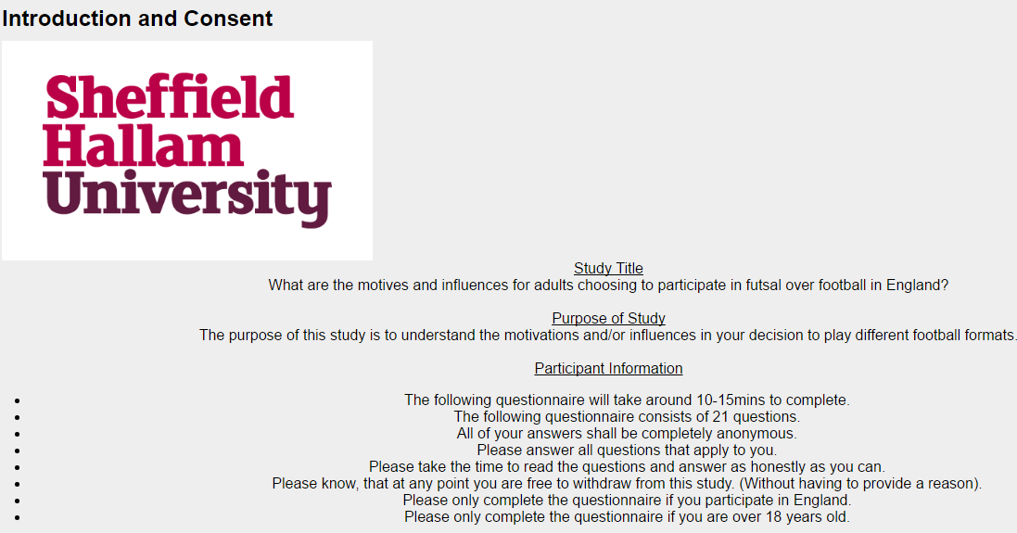

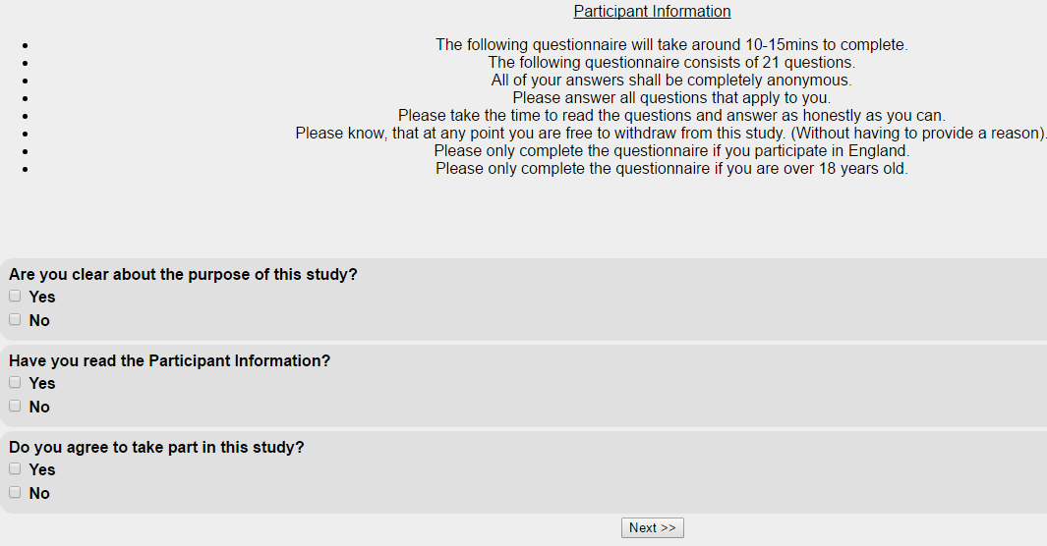

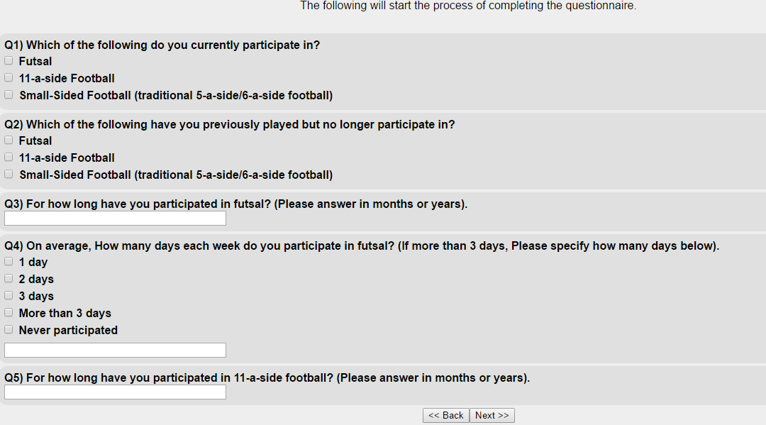

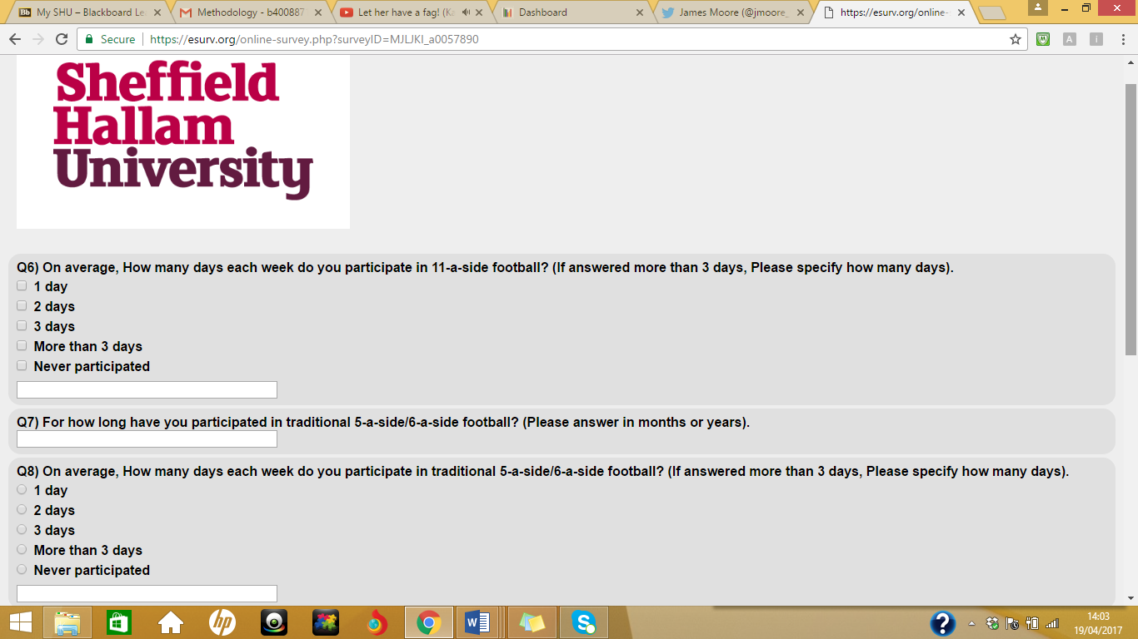

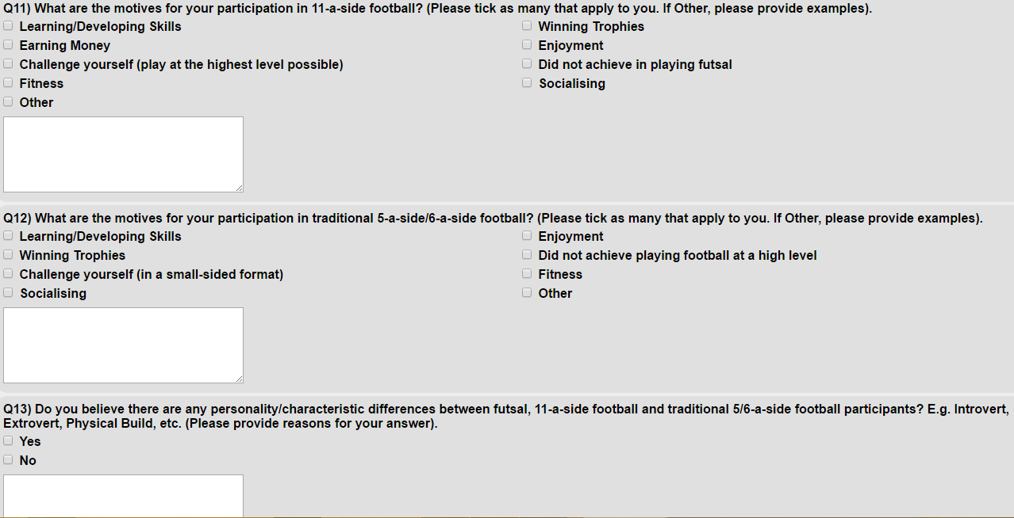

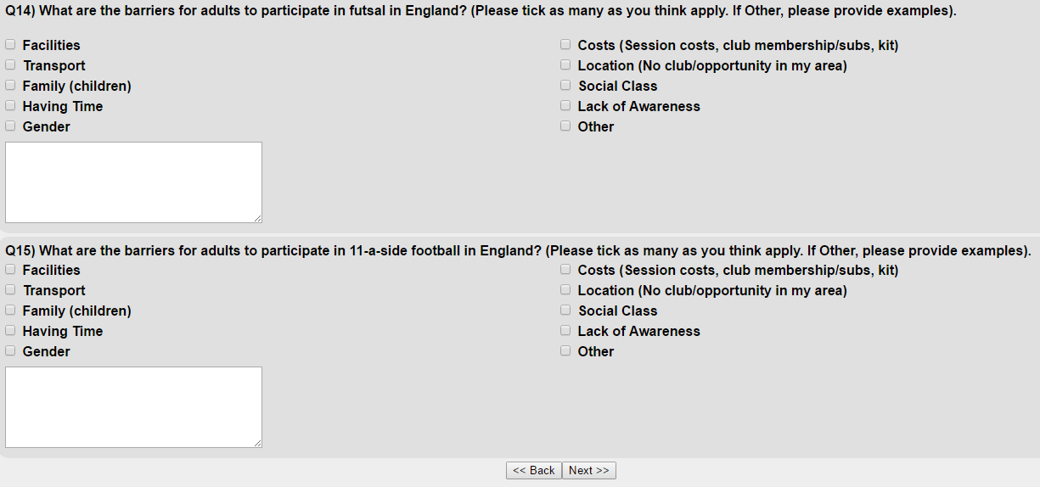

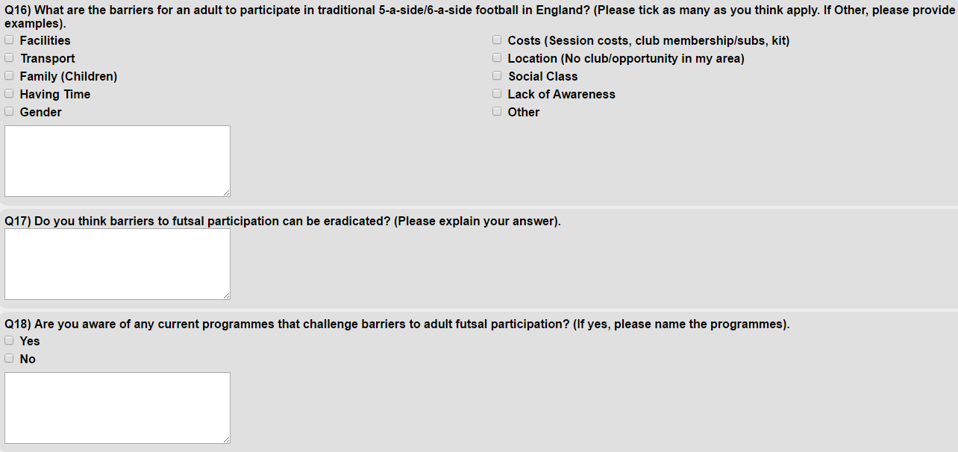

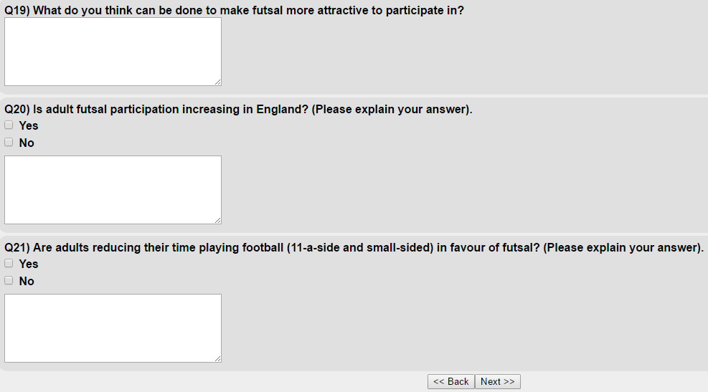

Appendix 4- Pilot Questionnaire Feedback Sheet

Appendix 5- Interview Questions
Interview Questions
- Do you currently or have you previously played futsal?
Follow-up questions:
- (If played in the past but not currently). Are you still involved in futsal in another capacity?
- (If never played futsal). How come you have never participated in futsal? /Have you ever considered playing futsal?
- How come you no longer participate in futsal?

- For how long have you participated/did you participate in futsal?

- Do you currently or have you previously played football?

- For how long have you participated/did you participate in football?
Follow-up questions:
- How come you no longer participate in football?

- In what format do you participate in football, 11-a-side or other small-sided formats (besides futsal)?

- What are the motives for you in choosing to play futsal?

- What are the motives for you in choosing to play 11-a-side football?

- What are the motives for you choosing to play small-sided football? (e.g. traditional 5-a-side/6-a-side)

- What do you think motivates other adults to participate in futsal?

- What do you think motivates other adults to participate in football?
- 11-a-side football
- Traditional 5/6-a-side

- Do you think there are any common characteristics in the people who choose to participate in futsal?
- In football? (11 and small sided)

- Do you think there are any social or cultural influences in an adults choice in choosing to play futsal or football (11 and small sided)?

- Are there any barriers to futsal participation in England and if so what kind of barriers?
- Is it possible for these barriers to be reduced or eradicated?

- Are there any barriers to football (11 and small sided) participation in England and if so what kind?
- Which do you think has more barriers to participation, futsal or football?

- Do you believe futsal participation is increasing in England and if so what makes you think this?

- Is it possible that more people are dropping out of football/reducing their time playing football in favour of futsal?

Appendix 6- Interview Transcript Accuracy Confirmation

Appendix 7- Coded Transcript
Participant 4 Interview Transcript
Key Codes:
Analytic Codes
Terms relating to physical build of a player/physicality of football
Fitness
Enjoyment
Terms relating to culture
In-Vivo Codes
Buzz for the game
Technically Gifted

Researcher: Participant interview number 4 er.., looking at the topic what are the motivations and influences for adults choosing to participate in futsal over football in England. The research objectives are to understand the motivations for adults choosing to participate in futsal over 11-a-side football, also to understand the motivations for adults choosing to participate in futsal over other small-sided formats such as 6-a-side and the traditional 5-a-side, and finally to understand why participants do not play futsal instead of football. Er.., just to confirm that you understand the study and you’re happy to take part in this interview.
Participant: Yeah, yeah that’s fine mate.
Researcher: Ok so, first question, do you currently or have you previously played futsal?
Participant: Erm.., currently play, mainly at recreational level erm.., and I have had national league experience as well in the past and, and also BUCS experience too.
Researcher: Ok er.., so you said you used to play at national league level er.., is there any reasons for why you don’t play at that level still?
Participant: Erm.., fitness, fitness personally. So nowhere near fit enough to, be able to play at that national league, at elite level erm.., and.., not enough time to dedicate towards erm.., playing, at that time sorry, to train, the fitness and training you’d have to go into. So it’s more easy for me as an individual to focus on playing recreationally and then I, I step in whenever I’m needed. If we’re ever really short of a player and in need, it’s me.
Researcher: Ok er.., do you currently or have you previously played 11-a-side football?
Participant: Erm.., played 11-a-side from roughly the age of well Jesus.., I’m, I’m 28 so when, I’m trying to think when I was 10 there was no cut-offs, so there was no, no staggered erm.., so we jumped from 7-a-side to 11 and I played 11-a-side until I was about 20 erm.., which was when I really got into futsal and I was playing Sunday league so I stopped playing Sunday league to, to get involved with futsal.
Researcher: Ok and have, do you currently or have you previously participated in other small-sided formats such as traditional 5-a-side or 6-a-side that has the rebound walls?
Participant: Yes I’m erm.., an administrator of an indoor sports centre which runs, runs 5-a-side leagues so I play 5-a-side on a weekly basis as well.
Researcher: Ok er.., do you, do you still play that?
Participant: Yes, yes still play it.
Researcher: Ok, how, how long have you played small-sided football for?
Participant: Erm.., probably 15.., 15, 16 years.
Researcher: Ok, so you, you just mentioned there about how you stopped playing 11-a-side football to start playing futsal.
Participant: Yep
Researcher: What, what were the motivations there for you choosing futsal over 11-a-side football?
Participant: Erm.., from, well as a, as a player I never really enjoyed the, the thought of getting up on a Sunday morning to go out in the freezing cold and play on a poor pitch which most of the park pitches in erm.., in and around [name of place] are erm.., to go and be kicked about by someone who’s still drunk from the night before. So when I got into futsal and discovered the national league and we discovered the national BUCS programme erm.., it was like a breath of fresh air because I wanted to carry on playing but I was fed up with getting up to play on a Sunday morning. So in terms of, it came more centrally to instead of wasting my time playing futsal, I was enjoying the game rather than going and doing something where I didn’t enjoy it as much because of the, because the situation was arising in each, each fixture.
Researcher: So would you say that you, you dropped out of football because you didn’t enjoy it no more and you was looking more for the enjoyment factor which you found in futsal?
Participant: I think yeah, I think at the time I dropped out it was down to time constraints and for me giving up, giving up my spare time, I, I have to be somebody who really enjoys what they’re doing and if I don’t enjoy it I find myself a bit, I find my interest wavering so I won’t do it. So if I wanted to carry on playing then I needed to find some form of the game that I really enjoyed and looked forward to going and playing and futsal was that for me.
Researcher: Ok so they sounded quite like erm.., intrinsic reasons, was there any external reasons that motivated you to choose futsal over football?
Participant: Erm.., in terms of, as a player erm.., I, I was always, I’m, I’m 5 foot 8. So in, in terms of my actual physique I was always a full back or, or a central midfield player. So when you step up to adult football erm.., you obviously reach a period where you are coming up against people who are a lot bigger than you in size. So I was finding myself in teams sometimes not getting minutes on the court, on, on the pitch erm.., because of my size and my, my physical stature. So when I found futsal it was like a breath of fresh air because it doesn’t matter if, if you’re comfortable on the ball you just play, it doesn’t matter who, who you are in it, it almost favours players of my, my size over bigger taller players who probably haven’t got as good a touch.
Researcher: That’s quite interesting. So would you say the, the stereotype of football that favours the early born and bigger players, would you say futsal is maybe a motivation for those that are late borns and not as big physically?
Participant: Well I think I, I look at, I look at some of the players that we have recruited over the years and I’ve played with and I’ve coached as well, and certainly we try and think, look at when will you try to sell futsal and we say well look as a footballer you probably wouldn’t get the chances to go and play at such and such a level erm.., because of your, because of your build which they’ve already known. A lot of players especially at national league level that I’ve come across are, have been in academies, have been released by academies, things like that. So when you.., a lot of them are that type of build of player and I, I think that as a futsal player there are more opportunities open to you erm.., being a smaller player than there are in mainstream football especially in this country.
Researcher: Why do you think that is?
Participant: Erm.., I think it’s something that’s er.., I think it’s developed over time in academies that they look for, they’re hooked on looking for these athletic players erm.., that will run all day erm.., have that work rate of er.., team leader you can, almost, it almost came about that, that you want players who are going to run all day, smash through tackles and get the ball forward as quick as possible and be quick erm.., and it, just get it over the top. Whereas actually when you look at some of the best teams of our generation, name probably Barcelona and Bayern Munich as the two. So these one’s, these are players, these are teams that have your smaller erm.., more erm.., more gifted technically erm.., more technically gifted bodies who, who can move a ball quicker than some of these other guys can run anybody er.., so I don’t think, I just think it’s a model that whatever reason is favoured it doesn’t necessarily work.
Researcher: Ok and when you were playing 11-a-side football, what were your motives for that or what was the influences for you playing 11-a-side football?
Participant: The influence of me playing? So why did I get into it or…?
Researcher: Yeah, yeah, so why did you participate in 11-a-side football?
Participant: Er.., I’ve always been a football fan from a young age erm.., so is something that obviously I always wanted to do, it’s almost bred into me. [Name of place] is a big football town so erm.., you, you grow up erm.., majority of people I’ve known well played football, all, also it was something my dad played, my grandad. So it was always something that I was going to do erm.., and then just over the years it was just something we did on a, on a, there go and watch [name of club], on a Sunday morning I’d get up and play.
Researcher: Oh ok and..,
Participant: So it’s almost like a cultural thing really.
Researcher: Yeah and what were the motives for you playing traditional 5-a-side or 6-a-side football?
Participant: Erm.., it was something, really, we did it as a, when we first started doing it erm.., we, we played in a, like a youth, like a youth club league erm.., where we, we basically broke 6 or 7 friends together and went and entered a tournament and then ended up playing a league, the centre where I now work, and then over the years since then I’ve kept, obviously enjoyed playing and then over the years since then, especially since I work at the sports centre erm.., it’s something I have continued to do and there I go, I go and play. Erm.., it’s good for custom, for the customer to see members of staff playing because it means that, with anything if you try and sell a product, if you use that product yourself it’s erm.., it’s a good thing and also it’s just a way of erm.., I work long hours and things like that, I’m keeping my own erm.., physical condition up.
Researcher: Yeah so again they sounded quite er.., intrinsic reasons there so you mentioned about playing with your friends and keeping your fitness up.
Participant: Yep
Researcher: Was there any external influences or motives for playing the other smaller-sided football?
Participant: Yeah I, I suppose you would again say sort of family and friends and so my dad had always played 5-a-side so I grew up with it, I didn’t fail on going to watch him play 5-a-side too, it was all something that, I knew I did that because that’s what dad did. You grew up knowing, especially in the sports centre where we play [name of sports centre], it’s quite a, it’s a big social environment so through the years pretty much everybody in the, in the city will have, will have at some stage been in [name of sports centre] to play 5-a-side football, if, if they play football, I would have imagined.
Researcher: Ok and.., we’ll move on now so not just for you personally but thinking about other adults as well. What motivations are there for other adults to participate in futsal?
Participant: Erm.., you know what at times I think that they, that they express it enough but big [noise interruption], for the time that you are playing erm.., there’s more contact time on the ball erm.., it’s obviously great for growing your fitness and your, what, what you’re trying to work because of, because of that contact time, the amount you’re involved in the game erm.., if you’re going to be giving up 20 minutes to an hour for a recreational game each week. For me, for what it gives you back, so in terms of enjoyment, the amount of involvement you have and the amount of work you have to put in to play the game successfully. Erm.., I don’t think there’s a better fitness tool to be honest.
Researcher: And just thinking about higher up now, so the national league. What are the motives there for adults choosing to play futsal, especially those that want to play at the national league at the highest level, is there internal or external reasons and which, is there more of one?
Participant: Erm.., so I think when people are introduced to the game, it’s obviously still fairly young in this country. Everybody talks about, within, within the, within the futsal circle is the buzz for the game of futsal. If you get that buzz you ultimately start to look at what, what routes there are to follow and how you can get higher in the game and, and if you discover the national league you probably realise there’s an opportunity for you to play national league, to represent your town and all of it is going towards that England call-up and being a part of that England squad. Which basically there will be a large percentage of players that will have that dream erm.., in terms of you er.., looking at things and the way, if I was a, an individual looking to get into it, you want to better yourself. So if you're playing recreationally, surely playing futsal recreationally you want to know whether you have what it takes to step up and be at a national league level as well and maybe beyond that and, and at least try that opportunity.
Researcher: Yeah, so just comparing futsal to the other small-sided formats that are out there with the traditional 5 and 6-a-side. Why would an adult be motivated to choose the traditional 5-a-side version rather than futsal do you think?
Participant: Erm.., I think you’ve hit the nail on the head with the word traditional it’s, it’s what they’ve known. So a lot of people erm.., especially in England we, we seem to be stuck in our ways and I think that because it’s what they know, because it’s what’s always been done, people automatically will choose that erm.., because we don’t allow change, we are a, a culture that likes to stick with what they, with what they do erm.., and so for me it would be because they wanna stick with what they do erm.., and also because they, it is a lot more accessible to them than what, what futsal is, so there are far, for every opportunity you have to play futsal, there are probably 4 or 5 different options to go and play 5-a-side.
Researcher: Yeah, so in that case, flip the question over, why would people choose futsal over, say the traditional 5-a-side version then?
Participant: If, again looking at experiences and erm.., and, and people we’ve got playing. Once you have played it, I think people realise that it’s a better game. Erm.., initially they probably don’t understand the differences but once they do understand the differences of it in terms of the rules, the, obviously the way it’s, the way it’s played with a different ball, the bigger goals. They like that, once they’ve participated, they like the fact they are doing something different and it’s all, think perhaps the game erm.., that we can play this game and people are intrigued about it but actually getting them across the line sometimes and getting them to go and, to go and try it can be a strain. I, I think that it almost needs to be promoted better, why it’s different and, and what the potential of the game is so how it’s professional abroad erm.., the fact that obviously all of these great players have, have grown up playing futsal erm.., as opposed to what we know in, in terms of our traditional 5-a-side and, and maybe people will start to get it.
Researcher: Ok and thinking about 11-a-side football now. Why, why would adults choose or not choose 11-a-side football over futsal?
Participant: I think they, they choose 11-a-side because it’s what they see being played. Erm.., and they wanna follow in the footsteps of, of a, so to speak, also see an exit route so through to semi-pro level, through non-league towards the football league and there again there’s still, there’s still that dream in pretty much every footballer I would say until a certain age that you’re going to make it. Whereas in terms of futsal I think when they, when they experience futsal it opens up a different avenue so if you look at it from what we’ve just said erm.., these players who have these aspirations to be the best they can be, may see futsal as an opportunity to, to go and play national, national league, to go and represent their country potentially, maybe go abroad and play professionally erm.., and suddenly this opens up different avenues to them, especially if they are gifted players and if they maybe had a poor experience within, within an academy structure this opens up something that they can potentially pursue.
Researcher: Ok I just want to touch on erm.., about, you mentioned the dream of playing professionally erm.., even for the semi-pro players. That’s something that in previous conversations has come up before, that phrase of the dream.
Participant: Yep
Researcher: Do you think that dream to play professional 11-a-side football is that largely motivated by intrinsic or extrinsic reasons?
Participant: Erm.., it’s gonna be, it’s gonna be your, your more external factors initially because erm.., everybody has a dream to be a footballer because of the, the lifestyle, the money they earn erm.., everything about it, it’s a lifestyle that people aspire erm…, to be, and everybody wanted to, in our generation everybody grew up wanting to be David Beckham erm.., that, that type of thing so that’s an external reason but then if you look at, look from within yourself if you play at any sort of level and you have any, in anything you do, you should be wanting to aspire to be the best you can be. So automatically if you, if you are a footballer playing Sunday mornings, Saturday afternoons within the non-league structure you’re gonna want to push yourself as far as you can go and test yourself against the best and that is gonna mean that if you want to test yourself then you, you have a dream to go and play professionally, to maybe go and represent your country, and everybody could and probably does at some stage in their life probably think they can go and do that.
Researcher: Yeah, so thinking about your experience in both futsal and football. Do you think there’s any different characteristics or difference in the personality of those that participate in futsal and those that participate in football?
Participant: Yeah I, I think there is erm.., you see from a, if you, from a technical aspect erm.., your characteristics, the type of player you probably look for are different. So as a point, you probably wouldn’t really get 2 big, well trained centre halves who might be your first names on the team sheet at a non-league level in, in football, be going and playing futsal. You’re, you’re not going to see that because they are pretty much going to kick everything clear. Whereas with in terms of futsal you will pick players who, I’m, I’m not gonna lie here, your smaller, more technically gifted erm.., quicker moving, better on the ball and in terms of your actual erm.., personality and the way that you play the game, again you’re not going to pick the players who will wanna run on erm.., smash, smash someone from the opposition to put a tackle in, chase the ball, almost your, your kick and chase type players you’re not gonna pick those up but you are gonna pick up these players who like to have touches on the ball, like to, like to try different things, like to erm.., move the ball quickly, like to play in those little pockets of space. They are the ones who will enjoy this game better than playing your traditional 11-a-side game.
Researcher: Ok and do you think there’s any social or cultural influences in an adult’s decision choosing to play futsal or choosing to play football?
Participant: Definitely yeah. I, I think people who, you see pockets of people open who come and play futsal. So as soon as one of them has an interest, you make it one player who sees it, finds an interest and then suddenly him and his friends turn up and play it. Erm.., but then you’ll very rarely, imagine that one player who’s had that initial interest went back to his friends and his friends were like why would you wanna play that, we play 11-a-side on a Sunday. If they had that reaction to it, would he come back and play, so it, it is definitely going to be governed by a reaction of a group of people to, to how the sport is played, as to whether you get people interested, cause let’s face it, again like I’ve already said we’re a culture that doesn’t like change. So the 11-a-side is the norm, it’s what people know, it’s what people are lead to believe is the best form of the game. Erm.., so when they’re growing up as they’re, they’re building a career up, whatever level of football that they play. When these opportunities to come and play futsal come along the, the current generation that play it, there’s still that little bit of stigma that they don’t like the difference of it and I think that’s something that needs to be developed at an earlier stage of their life, that people, it’s almost integrated into their learning that futsal is part of what they play and as you get erm.., as you move them on and players… [Technical Difficulty]. Culture will change.
Researcher: Ok erm.., you mentioned 11-a-side football being a norm as, in the English culture. Would you say that 5-a-side and 6-a-side versions are also a norm as well in English culture?
Participant: I think they are yeah. They, they’ve been integrated for so long that this is a form of football that is played in this country that, yeah that is the norm, especially when you have such a big commercial providers, your Powerleague, your Goals erm.., you play football and promoting it so heavily erm.., I think it is always going to, to be a norm for the culture and something that people, it’s almost an opposition to futsal. Whereas in fact it could embrace it and work side by side as we do at our centre, we try and get people to play both and try and show them the benefits of playing both erm.., and.., un, unfortunately you’re always going to get, and it’s, they’re going to take 10, 15 years before they even start to change, you’re always going to get with the current generation a little bit of frowned upon approach to futsal because it isn’t what they’re used to.
Researcher: So would you say it’s a mind-set thing and maybe the only way to change that is more promotion for futsal?
Participant: Yeah I think it is a mind-set thing. I think you can promote it as well, promote the benefits but I think we almost need to look at a complete change of, of approach because we can promote all day long to your 16 plus players at the moment. We really need to look at changing your, your angle and how you look at growing an interest in it is, let’s promote to those players who are just starting out. So when they are 6 to 10 and there first being introduced to, to playing futsal with their friends at school, playing futsal as part of a grassroots club, getting them in, sorry, playing football even as part of their grassroots club, let’s go and get them playing futsal as well because by the time they are 20, they will of had 10 years of knowing that futsal is a, a, a form of football they can enjoy erm.., and see the benefits of playing it. So when they get to 20 it’s just going to be part of their norm then so, so then futsal will, will, you will see a big shift in the way futsal features in terms of the culture in this country.
Researcher: Yeah, so currently do you think there’s any barriers to futsal participation in this country and is it possible for these barriers to be eradicated?
Participant: I think there are ba, barriers yeah erm.., two forms of the game we’ve spoke er.., the fitness side of it, the sort of outlook from, from the community, for all the communities both local and national towards the game of futsal is a barrier in itself and I think over time that will be eradicated but the work needs to start now if the children and it’s the children, and getting these players at such a young age integrated into the game and playing it, that will benefit it long term.
Researcher: Facilities is quite a popular barrier for most sports but also for futsal, do, do you think that’s true?
Participant: It is yeah but…. [Technical Difficulty]. Facilities erm.., as a, as a way of saying it can’t be done. If you go abroad, you go to France, you go to Spain, anywhere in Europe, anywhere in South America, you’ll see these little pockets and it’s like with the, it’s like our, what we call a MUGA in this country. So you’re multi-use games area they pop up on most street corners or at least a couple in every community. What the, what the kids found playing there, when they kick a ball and they’re, they’re playing, it’s futsal, it’s not football, they’ve got a futsal ball, they’re playing in futsal goals so your hockey sized goals and it’s futsal that they’re playing. So if everywhere has got tennis courts, every city has tennis courts, every city has sports halls that they use for badminton, basketball, whatever sport you name it. It doesn’t matter about the size at 6, 7 years old. What matters is getting a ball at their feet and getting them playing on a hard surface and I think we, we tend to, to use facilities as a barrier probably through laziness really because people don’t wanna go out and, and put the work into growing this game and they just, it’s, it’s easier to moan about it than it is to actually go out and put the work in, and put in the effort into making people understand what futsal is all about.
Researcher: Ok and another popular barrier for most sports is social class. Do you think that plays a part in an adult choosing futsal or football?
Participant: Erm.., maybe, maybe but I think with, I think with, I, I, I look at players I’ve played with and we’ve had people from all different backgrounds. Erm.., I think that your street footballers are your children that grow up in your, your more multi-cultural environments and your sort of less well-off areas of the city they will be the ones most likely to play it because they’ve grew up with a ball. Whereas if you’ve grown up in your richer areas and your more affluent areas, they are your people who have grown up and play, played 11-a-side erm.., they, they’ve been fortunate to play 11-a-side two days and a weekend, maybe had those opportunities to go and play as part of a erm.., talent identification process within a, within a erm.., football league club erm.., and, then that may be a barrier because if not, if they’ve not seen that opportunity early enough er.., I don’t understand that they, their culture and the way they’ve been brought up is to go and play 11-a-side always and what you find with your small-sided games is obviously you pick up a lot of these street footballers so maybe there is something that erm.., to that in futsal as well which then in-turn has its own barriers that at the moment in this country it’s quite an expensive game to play because of the costs of erm.., of obviously renting sports halls, referees erm.., taking the game, the FA’s ludicrous charges on, on erm.., coaching qualifications that type of thing, it is quite an expensive game to organise and grow, and so that’s a, that factor probably is a barrier towards it as well.
Researcher: Which do you think has more barriers to participation, futsal or football?
Participant: Futsal 100%
Researcher: What, do you think it has different barriers to football or similar ones?
Participant: I think they both have the same barriers, I think that futsal has more as well on top of it and also the, the barriers that are in football if we talk about 11-a-side and 5-a-side as well. They would tend to effect futsal more because of the cul, that cultural thing where if you have a few hours spare on a Tuesday evening and somebody said to you, oh you can go and, well we can go and play futsal on a erm.., at the local sports centre or we can go down to the 3G and play 5-a-side. Most groups of people currently in this country would still go and choose to play 5-a-side because it is what they’re used to so one of those barriers are that it is more likely to affect futsal than it is 5-a-side or even your, even your 11-a-side game.
Researcher: Ok and last couple of questions. Do you believe futsal participation is increasing in England and if so, what makes you think this?
Participant: I don’t, I don’t think er.., all levels are increasing at the moment. Erm.., I think what you’re finding is that when you look at the national league and the, the league like to, like to talk how, how the national league numbers are growing. What you’re actually finding is that the clubs that were once fives clubs playing in a recreational league they’re seeing fives numbers dwindle and, and they’re wanting to continue, these are the people that are enjoying the game and want to carry on playing it so they will automatically join the national league. Where it is growing is in the kids, in the futsal, in the kid’s game and as these, as these youngsters are being introduced to it they’re getting that buzz at a younger age and they’re wanting to play more, and I think that is where the growth will come and I don’t actually think you will see a massive change in the adults game for a number of years but the, the junior thing should continue to, to thrive and in-turn that will boost the numbers at university level and at college sport level, and then eventually that will obviously filter up as people get older into the, into the adult game as well.
Researcher: Ok and speaking about adult futsal participation. Do you think it’s possible that maybe more people are dropping out of football in any format or reducing their time playing football in favour of futsal?
Participant: Well personally that’s what I did and certainly for the group of players we now have together at [name of club] erm.., that is what pretty much all of them have done bar, bar 2 or 3. Erm.., I think that people, especially in [name of place], in the city erm.., 11-a-side adult numbers are dwindling whereas 5-a-side’s numbers and small-sided games are booming. So erm.., automatically people will drop out to go and play 5-a-side football and probably futsal because it’s more accessible. However, we have to and have arranged to promote futsal and the benefits of futsal over than the traditional 5-a-side so that when those people do drop out they realise that by choosing futsal they can choose something different that is, is obviously an option for them instead of, instead of more traditional formats that tend to go a bit stale and they may er.., eventually drop out of them as well.
Researcher: So do you think if the opportunity was there for adults to play more futsal, do you think they would choose that over football?
Participant: Yeah I do, I do. I think people play it they, they start to understand and it needs to take its time sometimes, they start to understand what it’s about erm.., the differences, the benefits of it and erm.., I touched on it earlier, that, that buzz for the game, once they develop that buzz for the game as it probably has done me and as it has done you, listen, you, you start to realise that this is a game that captures your enjoyment and makes you want to continue playing. Whereas you probably come up against the same issues playing your more traditional small-sided games as you do in the 11-a-side and if I like at, right back to the reasons I stopped playing 11-a-side, there are forms of 5-a-side and 6-a-side and in [name of place] that I wouldn’t play for the exact same reasons, you come against the players who are gonna kick lumps out of you, you’re gonna play on a, on a cold, cold court, middle of winter is dark, you don’t wanna be going out to play erm.., in a cold and wet environment. So futsal is a, is a much more attractive option I’d say, go and play in a clean sports hall, indoor it’s warm, the focus is on playing with the ball rather than how high you can kick your opponent and I just think it’s a much better form of the game than anything we’ve been brought up erm.., to play in this country.
Researcher: Ok thank you for that. That concludes the interview and we’ll stop recording now.

Appendix 8- Respondents views on futsal participants being more tactically aware, thinking more and better technical ability
Participant | Comment
Questionnaire Respondent | More tactically aware players tend to play futsal I think. I would associate physical players with 11-a-side and 5-a-side, similar to classic English style of play. Whereas futsal is faster and more tactical, so players tend to rely more on technical components over physical characteristics.
Questionnaire Respondent | There are differences because in football it is a lot more physical. Whereas in futsal it is about having a good first touch, technical ability and very good at keeping possession.
Questionnaire Respondent | Futsal is more tactical and requires close control skills, as well as faster decision making.
Questionnaire Respondent | Futsal is a technical and tactical battle as opposed to the physical battle of 5-a-side and 11-a-side football.
Interviewee 4 | Whereas with in terms of futsal you will pick players who, I’m, I’m not gonna lie here, your smaller, more technically gifted erm.., quicker moving, better on the ball.

Appendix 9- Respondents views on 11-a-side football being more physical and aggressive
Participant | Comment
Questionnaire Respondent | 11 a-side football is more physical and requires therefore to be stronger than in futsal.
Questionnaire Respondent | 11 a side is more physical and more aggressive.
Questionnaire Respondent | 11 a-side is mob mentality.
Questionnaire Respondent | I would associate physical players with 11-a-side.
Questionnaire Respondent | There are differences because in football it is a lot more physical.
Questionnaire Respondent | Futsal is a technical and tactical battle as opposed to the physical battle of 5-a-side and 11-a-side football.
Interviewee 1 | There’s a lot more sort of aggressiveness in football.
Interviewee 2 | These guys will be probably more suited to 5-a-side or football because of their aggressive nature.

Appendix 10- Respondents beliefs on English culture not liking change
Participant | Comment
Interviewee 2 | I think probably the people that are playing 5-a-side maybe they are a bit more resistant to change erm.., maybe not just in, in a football sense but in life in general and you know maybe they don’t see futsal as something, I think they perhaps see it as something different, something, something they don’t fancy because it is a change and they don’t like change.
Interviewee 3 | Because it’s what they’ve always done, you know er.., humans are a creature of habit, English typically er.., you know, we stick with what we know, we feel comfortable in certain environments er.., anything which is new, ooh, ooh not sure about that.
Interviewee 4 | So a lot of people erm.., especially in England we, we seem to be stuck in our ways and I think that because it’s what they know, because it’s what’s always been done, people automatically will choose that erm.., because we don’t allow change, we are a, a culture that likes to stick with what they, with what they do erm.., and so for me it would be because they wanna stick with what they do.

Appendix 11- Respondents views on futsal offering a more competitive structure than small-sided football
Participant | Comment
Interviewee 1 | I mean you see a lot of 5-a-side teams set up who, you know they’re work teams, they’re pub teams, you know they’re, they’re just mates teams and, the FA fives leagues or futsal you, you see professional clubs, you know, well I say professional clubs but they act in a professional manner and they recruit players or players come to them because they want to play and compete and progress you know. You don’t normally get pub teams or work teams playing futsal, that, that’s something that could happen in the future but I just think the culture of futsal as we’ve already said is more of a progressive, competitive one, rather than the recreational elements of 5-a-side.
Interviewee 2 | More enjoyment when you’re playing competitive and you’re playing for something, and that, that was in futsal.
Interviewee 3 | I think you know, the people who have made that transition they’re almost pushing for it to be a bit more professional set up.

Appendix 12- Respondents views on futsal being more expensive in contrast to football’s jumpers for goalposts approach
Participant | Comment
Interviewee 1 | Futsal is played indoors and normally that obviously costs more money.
Interviewee 1 | You can’t normally get into a, a venue and play futsal without paying money, and people just can’t do that whereas you can have jumpers for goalposts outside.
Interviewee 2 | I think facilities is the biggest one and the, and the fact it is a small sport and for everybody else it’s an unknown sport. Football is known worldwide, so you know it’s like everybody in England knows what football is and so that and facilities not available in futsal I think that’s a bigger barrier than anything.

